

**Module Title : Design and Developing Website**

**Assignment Title : Standing Desks Ltd**

**Examination Cycle : Spring 2024**

**Candidate Name : SAUNG EAINDRAY MIN**

**Candidate No : P00207243**

**Centre Name : KMD COMPUTER CENTRE (YANGON)**

**Submission Date : 20 - January- 2024**

**Important Notes :**

* Please refer to the Assignment Presentation Requirements for advice on how to set out your assignment. These can be found on the NCC Education *Campus*. Scroll down the left hand side of the screen until you reach Personal Support. Click on this, and then on Policies and Advice. You will find the Assignment Presentation Requirements under the Advice section.
* You must familiarise yourself with the NCC Education Academic Dishonesty and Plagiarism Policy and ensure that you acknowledge all the sources which you use in your work. The policy is available on Campus. Follow the instructions above, but click on Policies rather than Advice.
* You must complete the **‘Statement and Confirmation of Own Work’**. The form is available on the Policies section of *Campus*. Scroll down the left hand side until you reach Personal Support. Click on this and then click on Policies and Advice.
* Please make a note of the recommended word count. You could lose marks if you write 10%more or less than this.
* You must submit a paper copy and digital copy (on disk or similarly acceptable medium).Media containing viruses, or media which cannot be run directly, will result in a fail grade being awarded for this module.
* All electronic media will be checked for plagiarism.

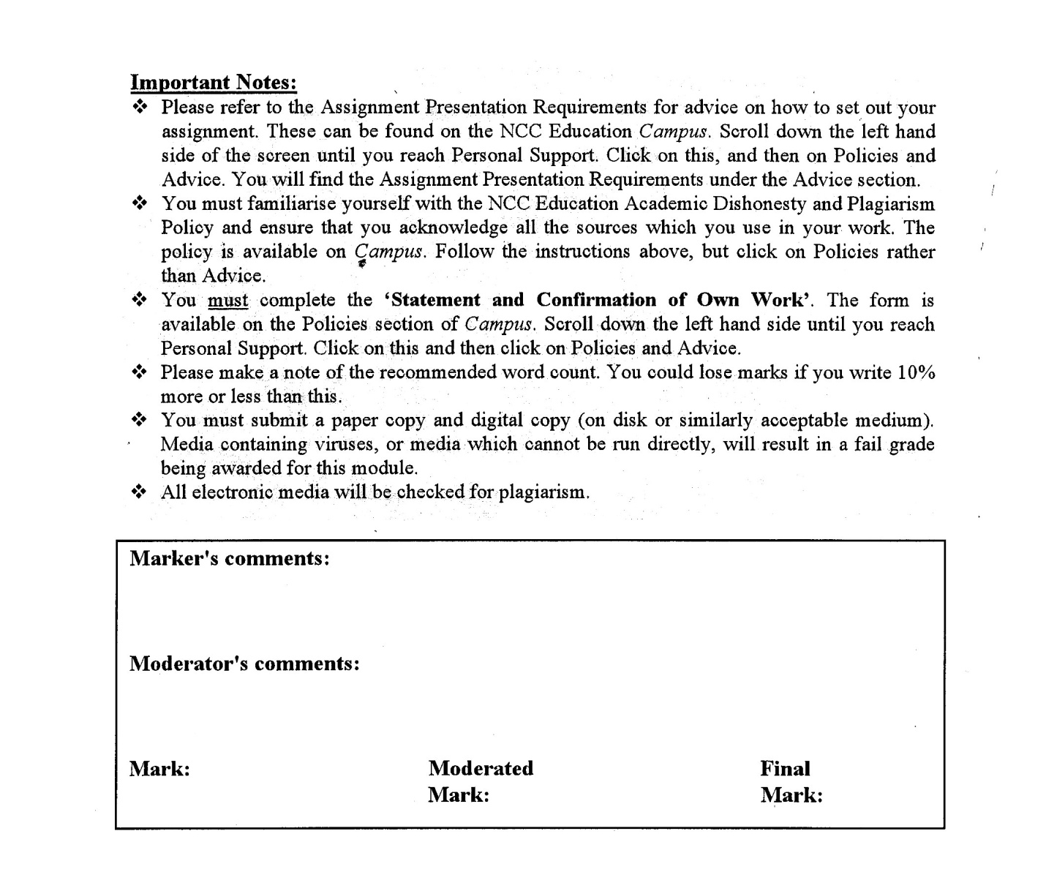



**Statement and Confirmation of Own Work**

**Programme/Qualification name: L4DC**

***All NCC Education assessed assignments submitted by students must have this statement as the cover page or it will not be accepted for marking. Please ensure that this statement is either firmly attached to the cover of the assignment or electronically inserted into the front of the assignment.***

**Student declaration**

**I have read and understood NCC Education’s Policy on Academic Dishonesty and Plagiarism.**

**I can confirm the following details.**

**Student ID/Registration number : P00207243**

**Name : SAUNG EAINDRAY MIN**

**Centre Name : KMD COMPUTER CENTRE (YANGON)**

**Module Name : DESIGNING AND DEVELOPING A WEBSITE**

**Module Leader : SHAIN THU**

**Number of words** **: (1097) WORDS**

**I confirm that this is my own work and that I have not plagiarised any part of it. I have also noted the assessment criteria and pass mark for assignments.**

**Due Date : 20 January 2024**

**Student Signature : Saung**

**Submitted Date** **: 19 January 2024**

# Table of Contents

Contents

Table of Contents 3

**Introduction** 4

**Task1- Website Design Screenshot** 6

**Task 2-CSS** 58

**Task 2-CSS** 59

**External CSS** 59

Task 3- Using the W3C validation service 150

**Task 3** 151

**Test the website with W3C validation service** 151

**Using a relevant screen reader** 157

**How the site works for disabled users** 160

**Differences between TWO (2) browsers.** 160

**The amendments that had been made.** 162

**Test Report** 164

**The role of the W3C.** 164

**Task 4- Critical evaluation** 165

**a) tools, techniques and software used to develop the website.** 166

**b) Intuitive interfaces and User Experience.** 166

**c) TWO (2) accessibility features** 167

**d) Recommend for further development** 167

**References** 168

Candidate checklist 170

# **Introduction**

An ecommerce website is essential in today's company environment, and Standing Desks Ltd hopes to increase its visibility with an e-commerce website that is focused on the needs of its customers. This project requires the selected developer to produce a brief HTML/CSS prototype that highlights the company's standing desks and their health benefits. The goal is to provide students with real-world web development experience while satisfying industry standards and client expectations.

**Task 1**

**HTML**

# **Task1- Website Design Screenshot**

HTML, Hyper Text Markup Language, is a common markup language used to create webpages. Using HTML elements, which are the fundamental components of a webpage, such tags and attributes, it enables the construction and organization of sections, paragraphs, and connections. (S, 2023)

The following screenshots are the webpages that I created for my assignment.

**Home Page**

In, Home page there are company logo, navigation bar, website cover and company name. In navigation, there are 5 pages containing. In addition, there are also drop-down features in “Item” page navigation. There are also eight sections in Home Page. Such as “Home-cover”, “Coupons and Voucher”, “Benefit”, “Item-video”, “Discount-item”, “Shipping and Delivery”, and “Subscription” section. Moreover, Modal pop-up and footer section are also included.

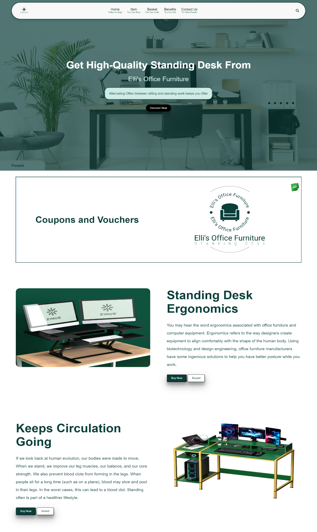Figure(T1_1.1)

Desktop View of Home Page

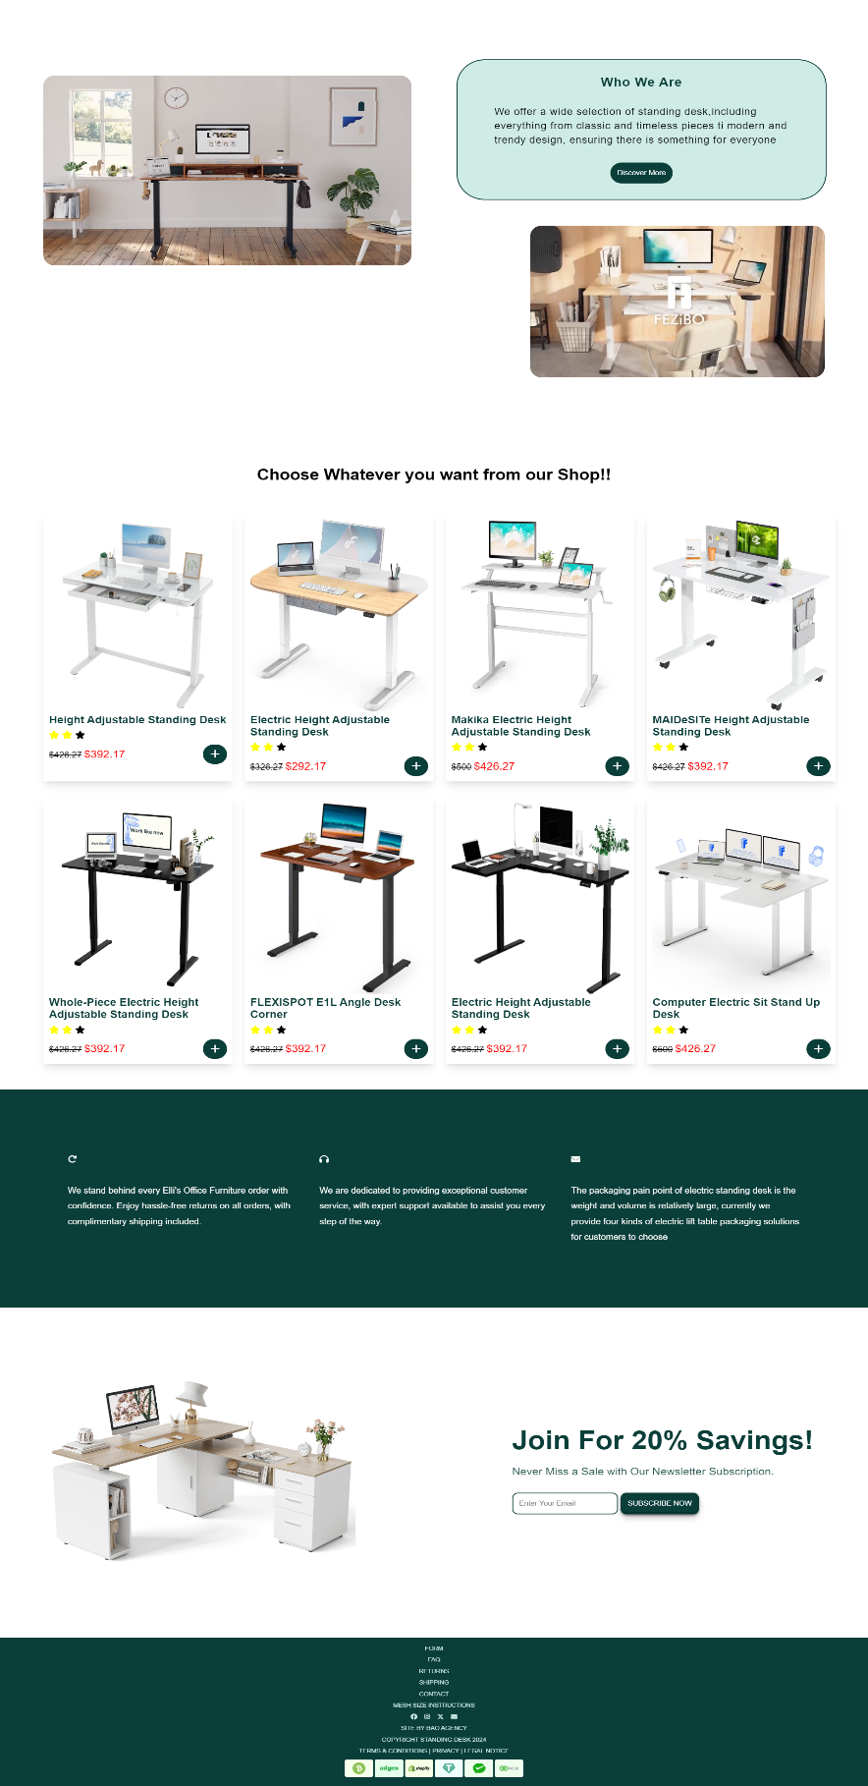

Figure(T1_1.2)

Desktop View of Home Page

**Chrome View**

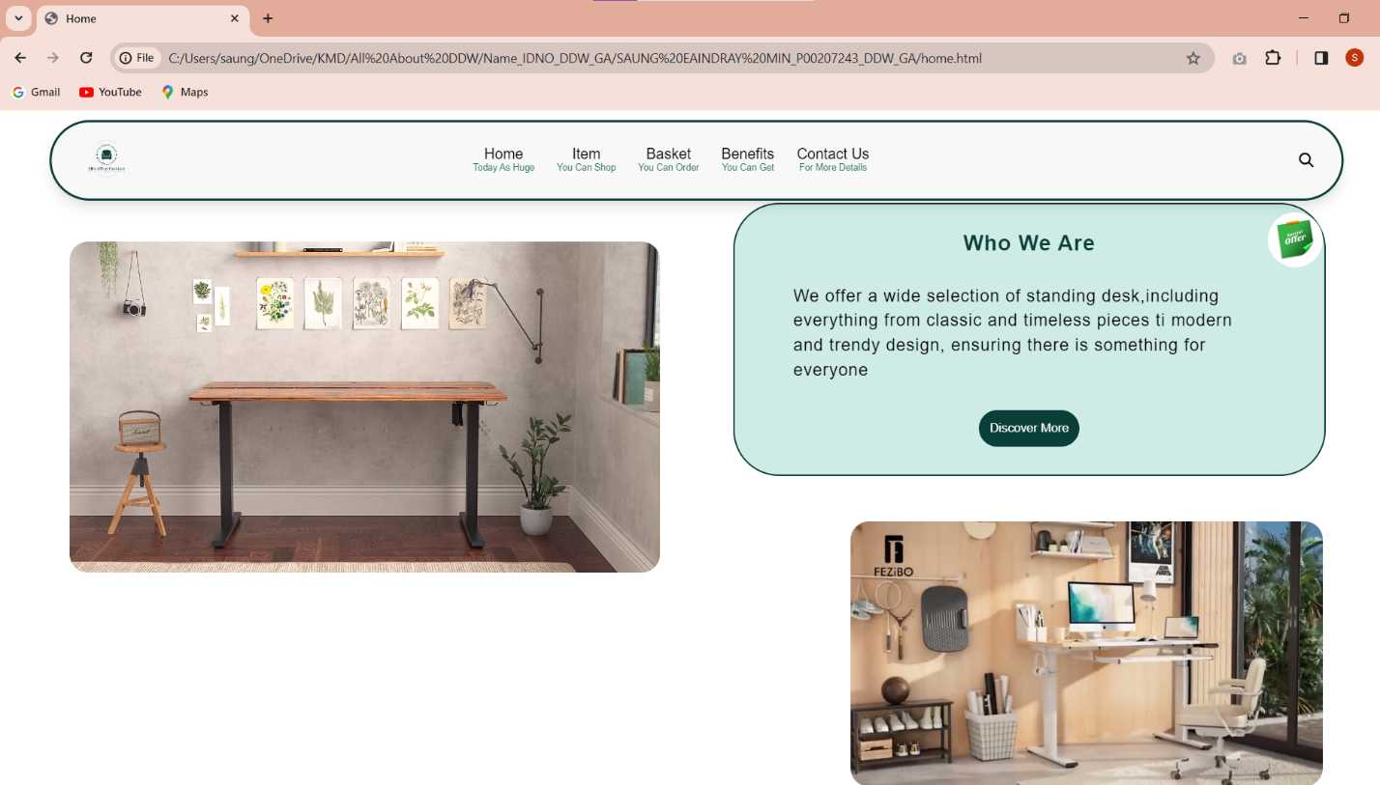

Desktop View of Home Page in Chrome Browser

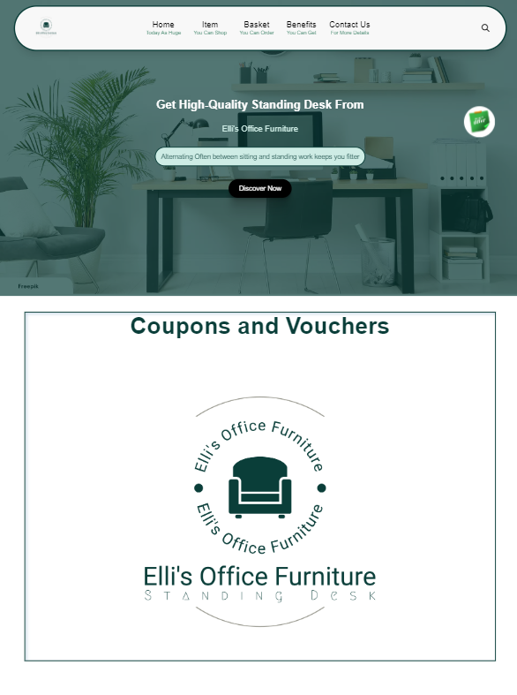

Figure(T1_1.3)

Tablet view of Home Page

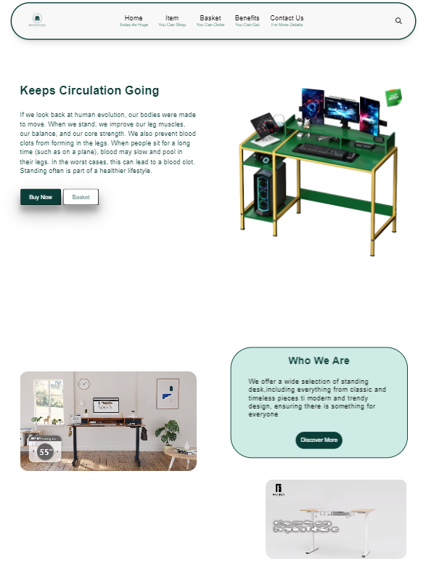

Figure(T1_1.4)

Tablet view of Home Page

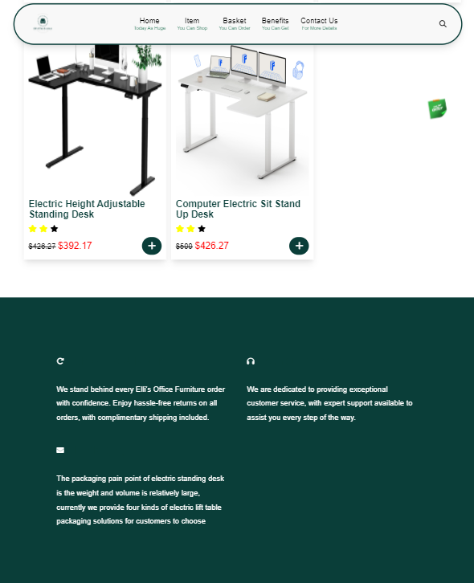

Figure(T1_1.5)

Tablet view of Home Page

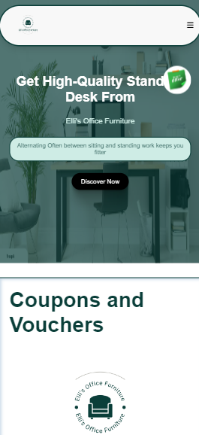

Figure(T1_1.6)

Mobile view of Home Page

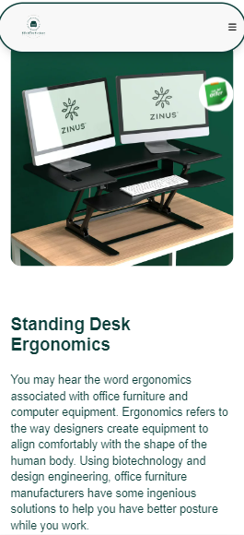

Figure(T1_1.7)

Mobile view of Home Page

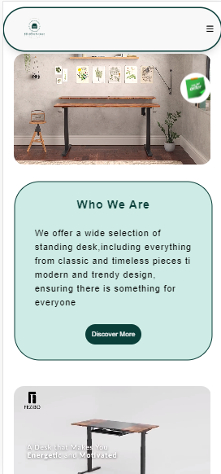

Figure(T1_1.8)

Mobile view of Home Page

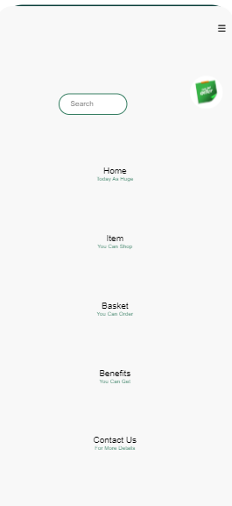

Figure(T1_1.9)

Mobile view of Navigation

**ItemDeatils Page**

In “Item Details” Page, there are all information about all standing desk category and different type of standing desk. In addition, customers can also choose the color and can watch set up video. There is also navigation bar, “Subscription” section and “Footer” section.

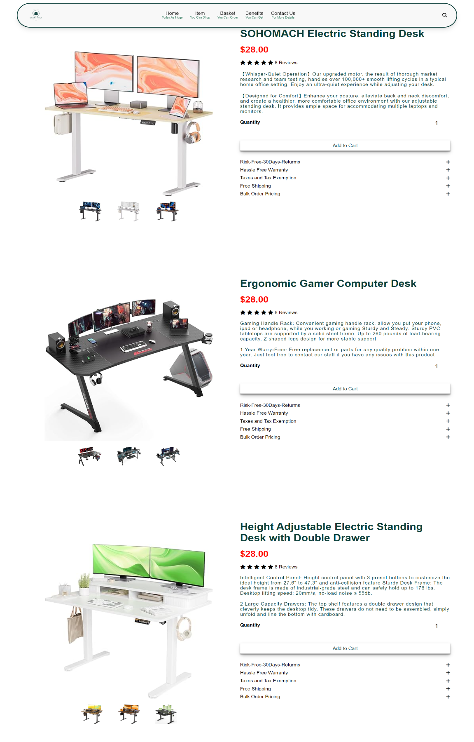

Figure(T1_2.1)

Desktop View of Item Details Page

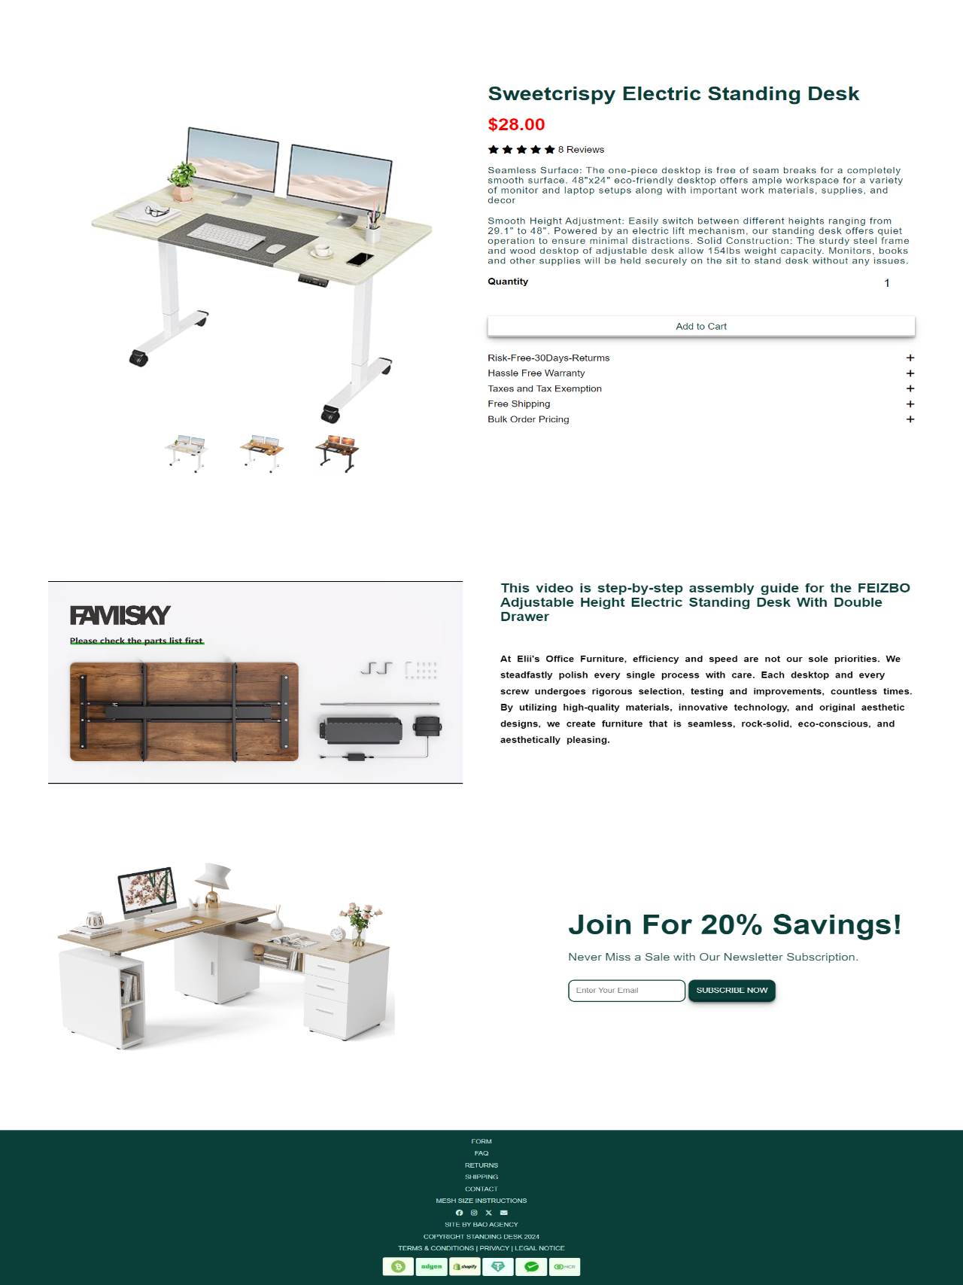

Figure(T1_2.2)

Desktop View of Item Details Page

**Chrome View**

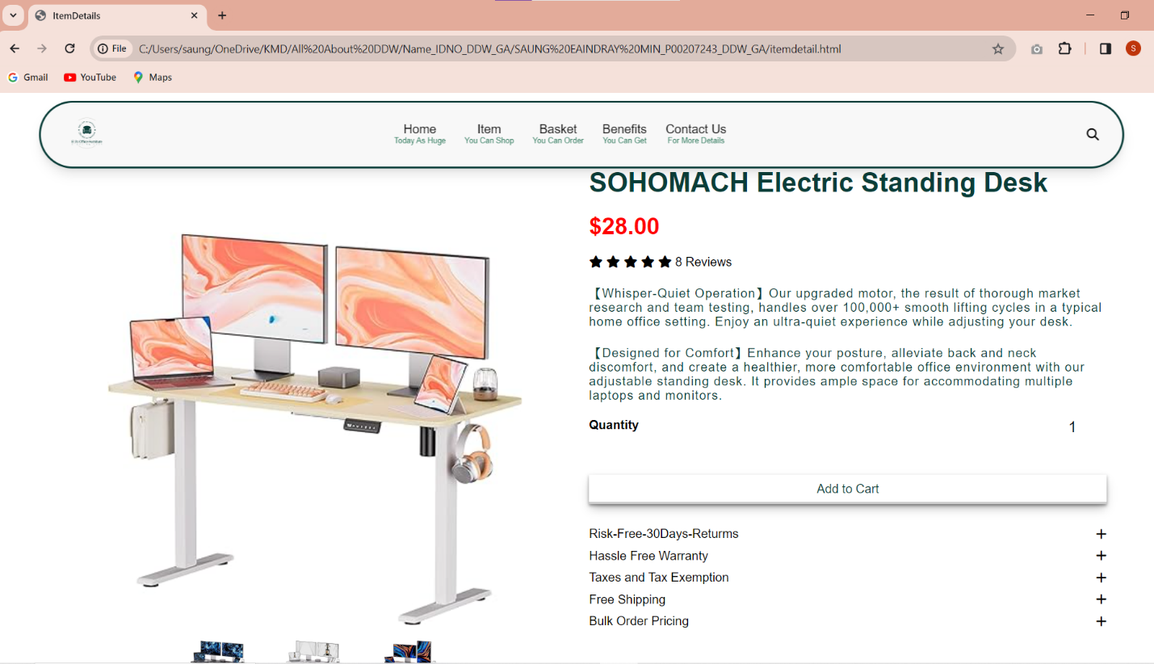

Desktop View of Item Details Page in Chrome Browser

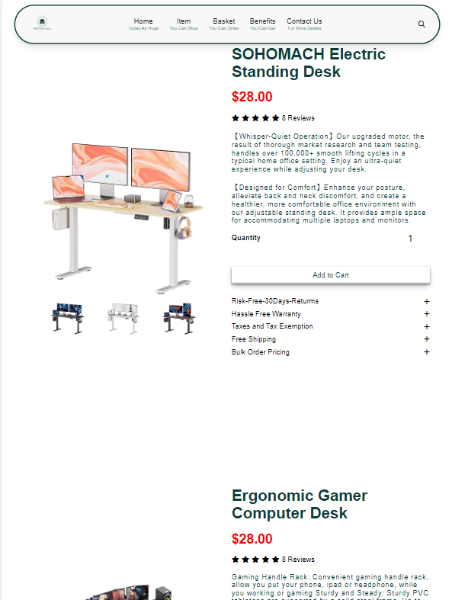

Figure(T1_2.3)

Tablet View of Item Details Page

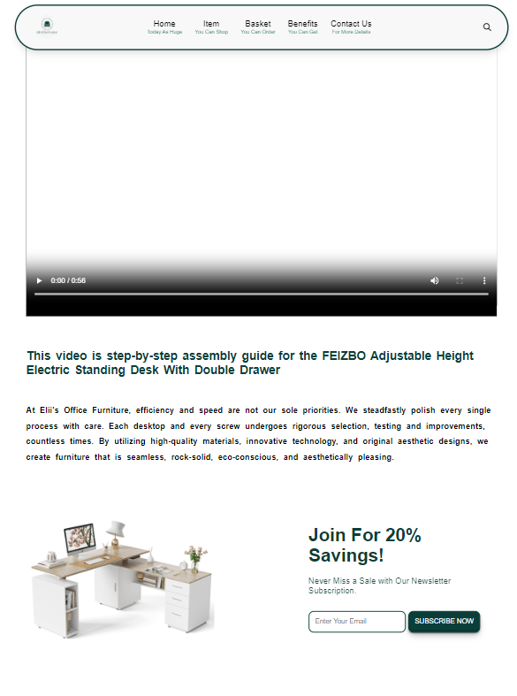

Figure(T1_2.4)

Tablet View of Item Details Page

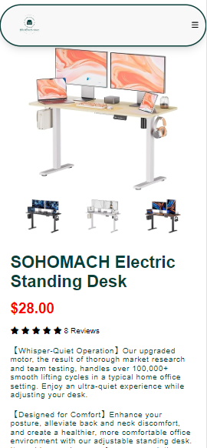

Figure(T1_2.5)

Mobile View of Item Details Page

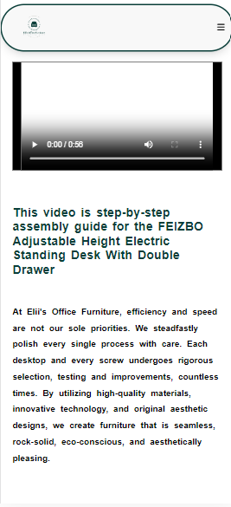

Figure(T1_2.6)

Mobile View of Item Details Page

**Contact Us Page**

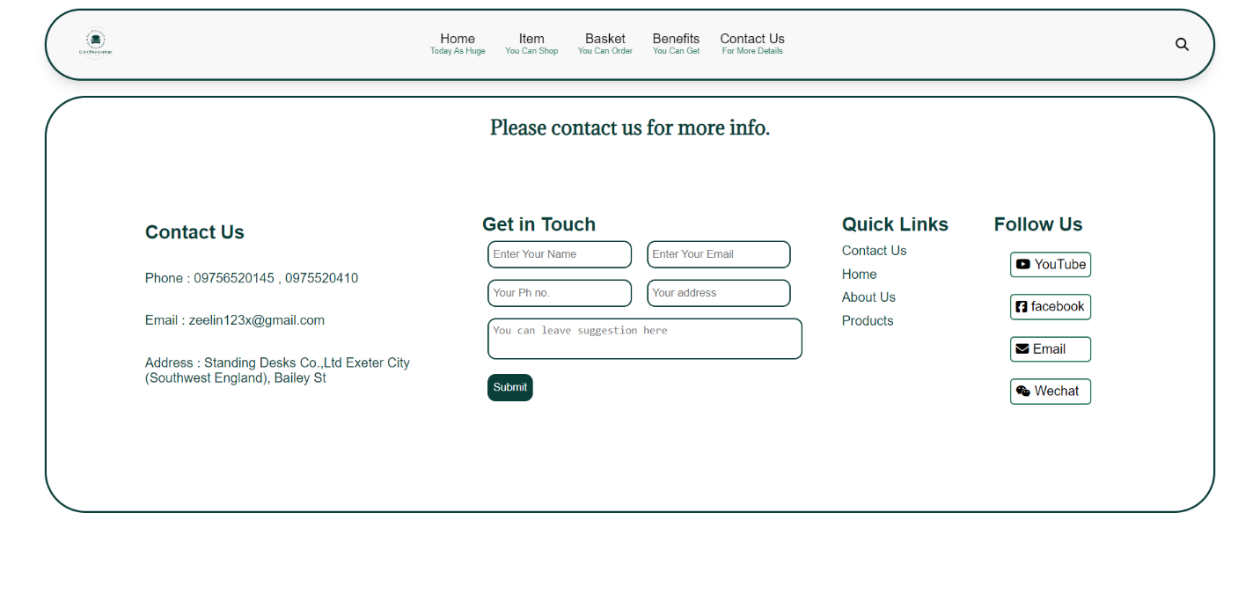In “Contact Us” Page, there is only contact information, navigation bar, and social media icons.

Figure(T1_3.1)

Desktop view of Contact Us Page

**Chrome View**

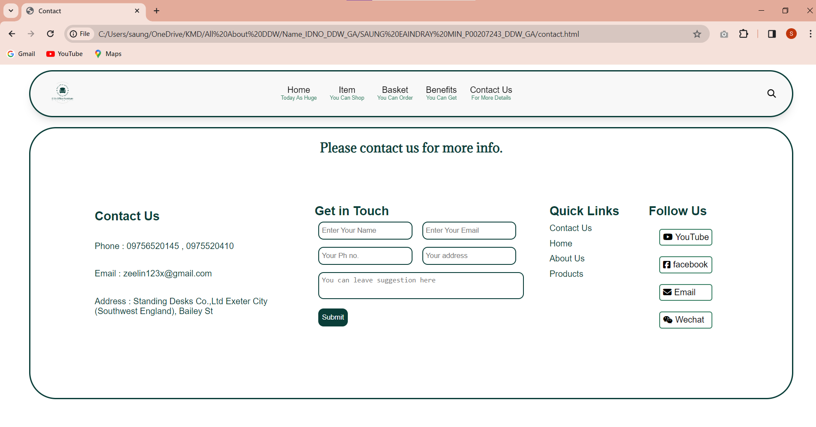

Desktop view of Contact Us Page in Chrome Browser

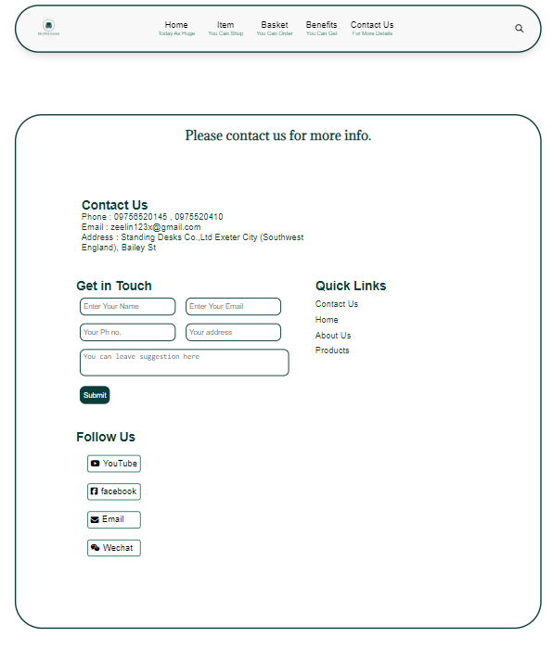

Figure(T1_3.2)

Tablet view of Contact Us Page

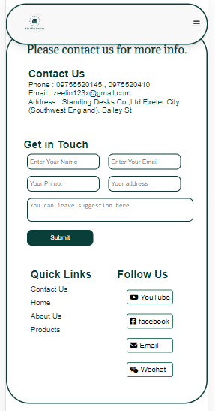

Figure(T1_3.3)

Mobile view of Contact Us Page

**Item Page**

In “Item” Page, there are special offer at the top, Best Seller Item list and customer can choose different category section, and item list. Navigation bar, “Subscription” section, and “Footer” section are always in all webpages.

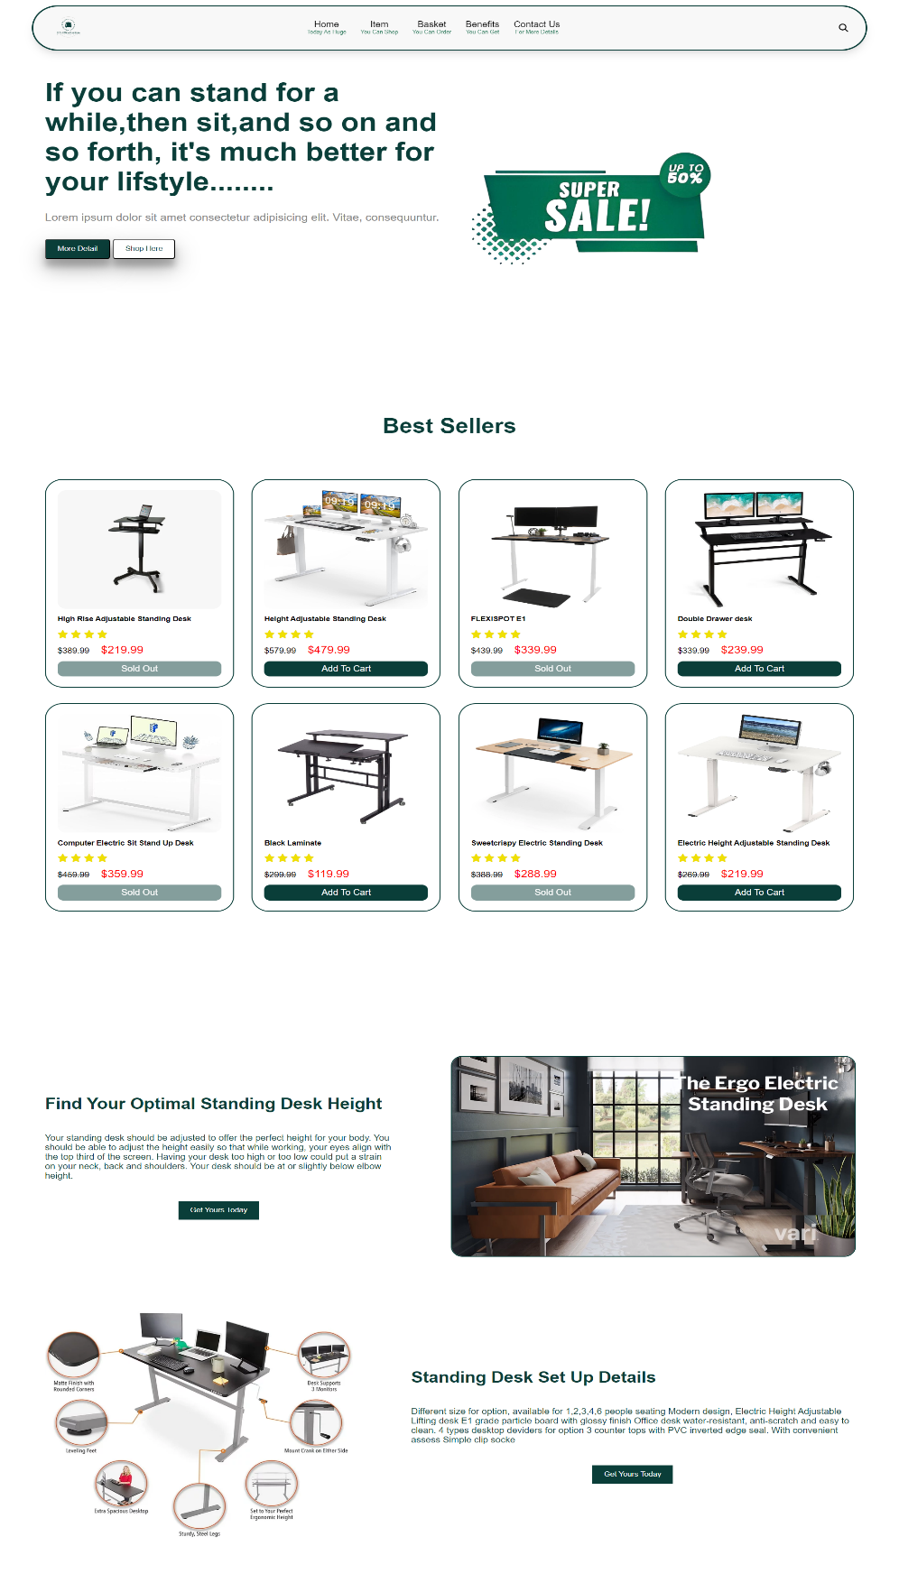

Figure(T1_4.1)

Desktop View of Item Page

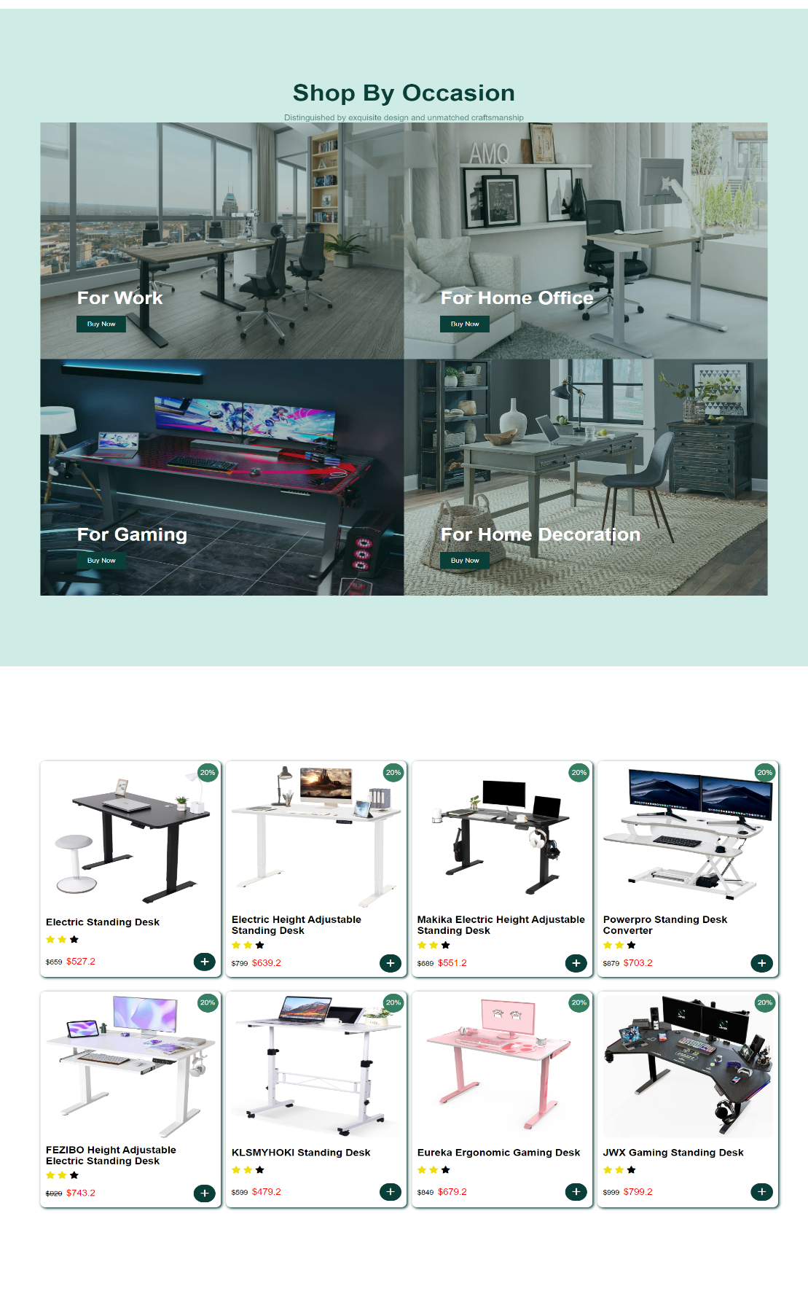

Figure(T1_4.2)

Desktop View of Item Page

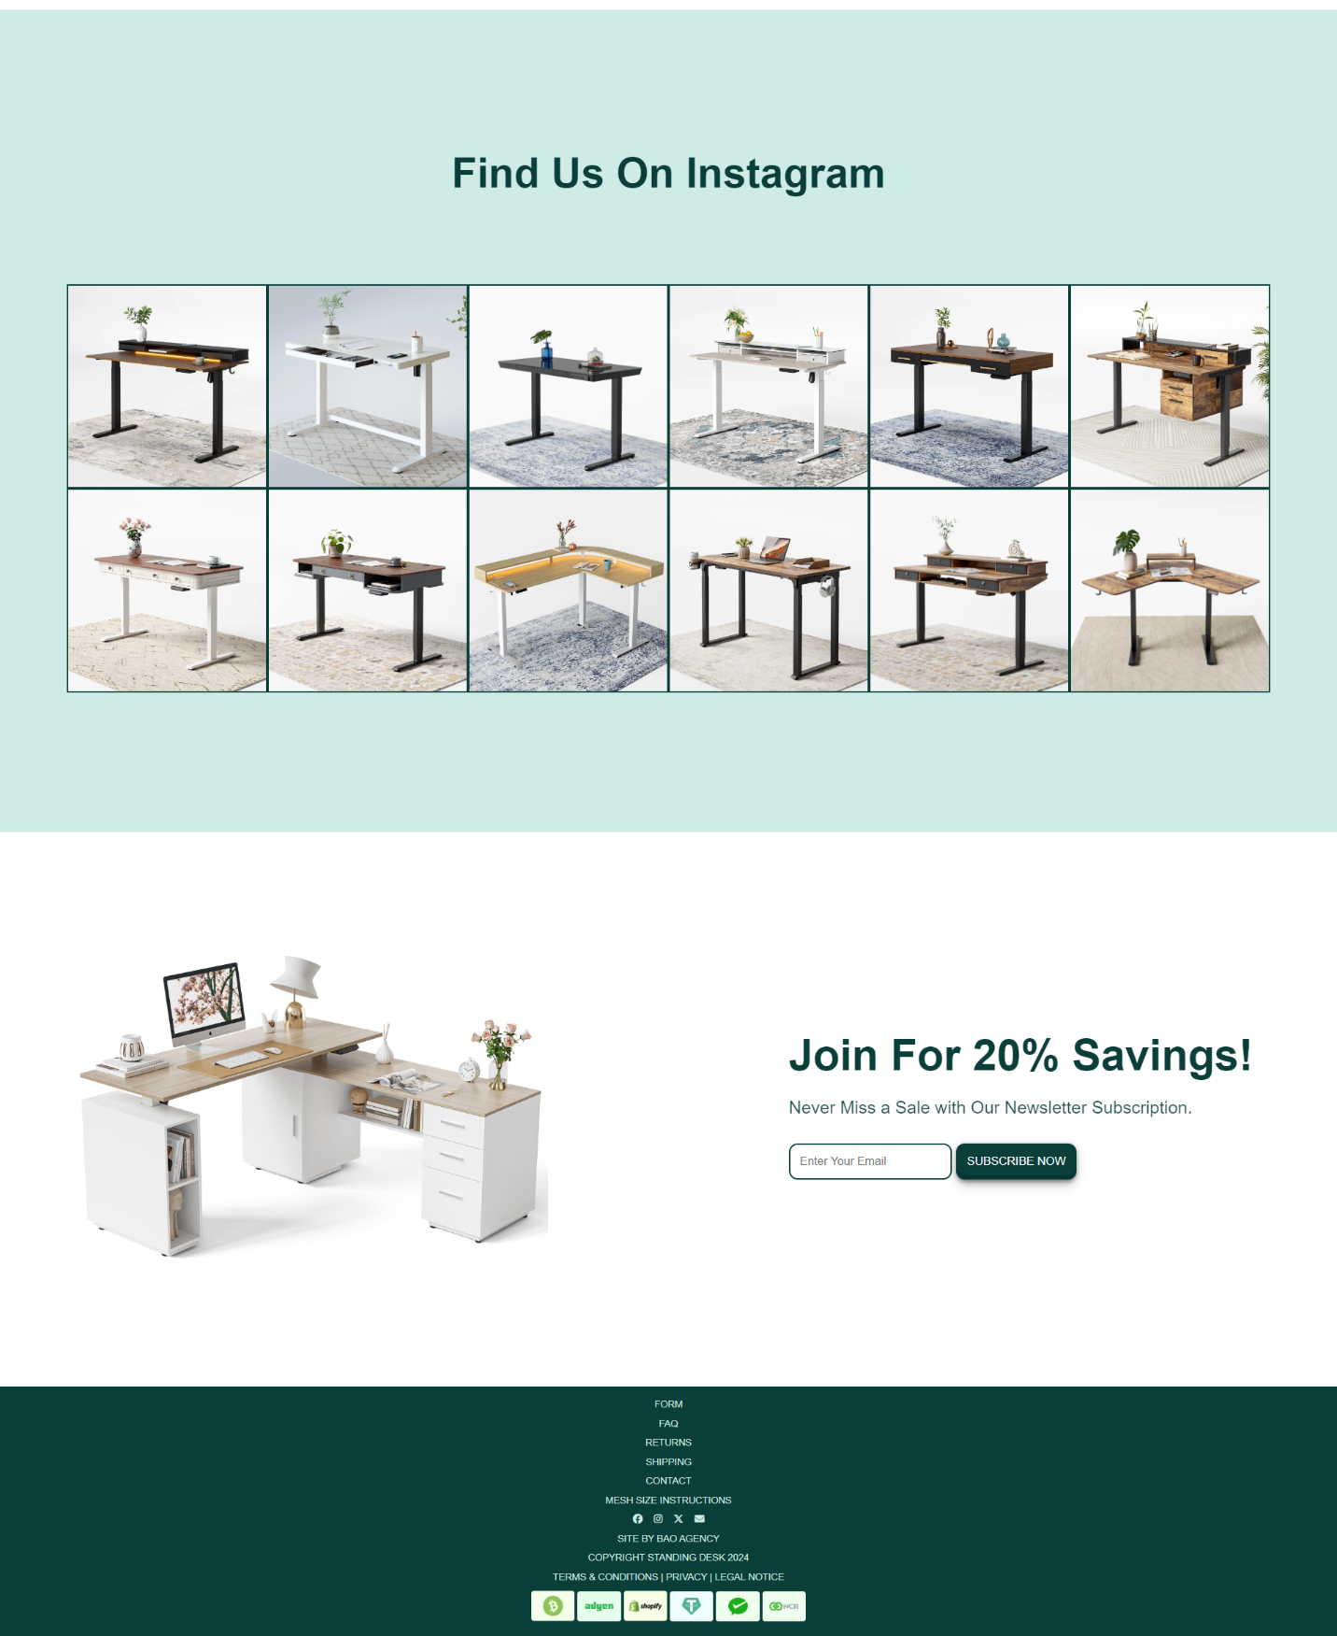

Figure(T1_4.3)

Desktop View of Item Page

**Chrome View**

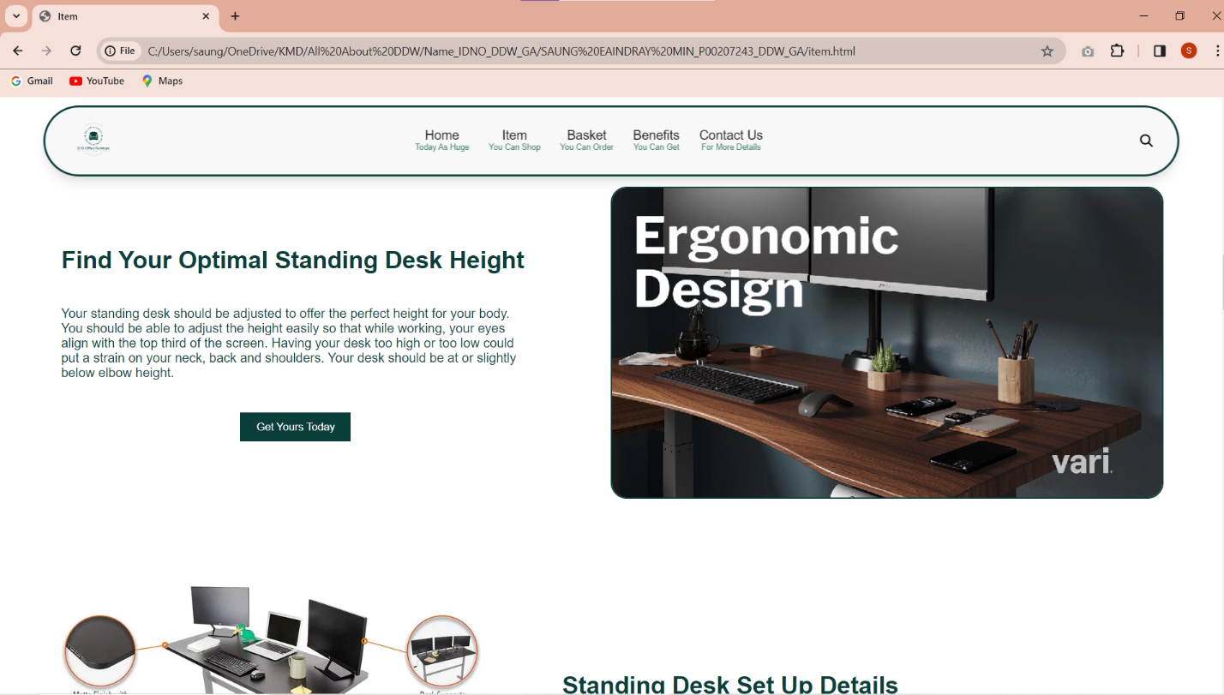

Desktop View of Item Page in Chrome Browser

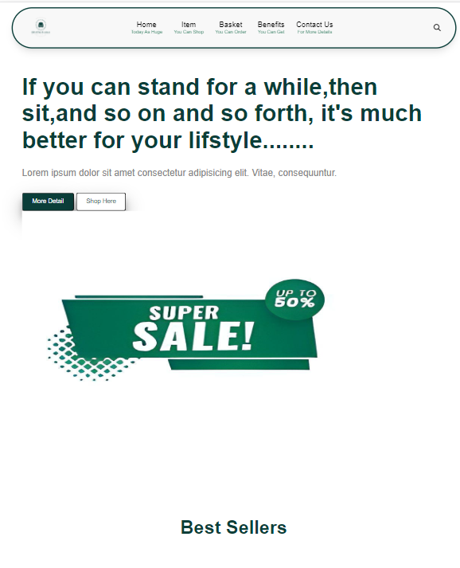

Figure(T1_4.4)

Tablet View of Item Page

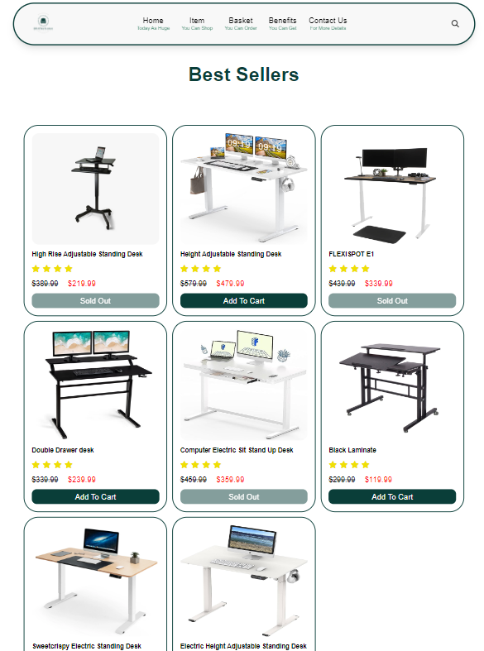

Figure(T1_4.5)

Tablet View of Item Page

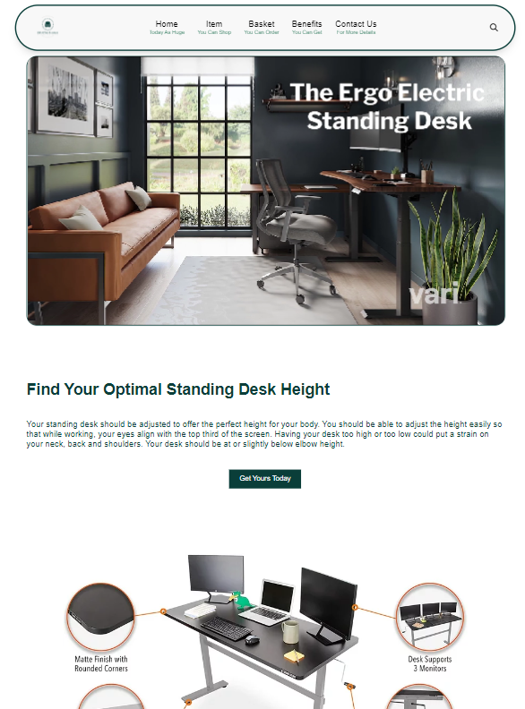

Figure(T1_4.6)

Tablet View of Item Page

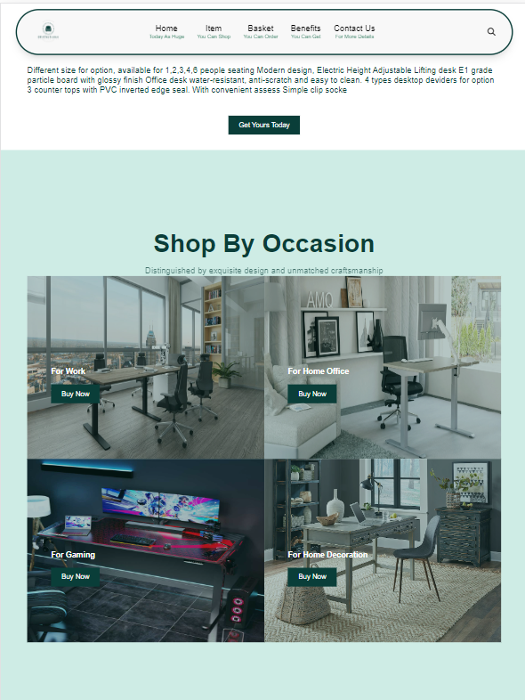

Figure(T1_4.7)

Tablet View of Item Page

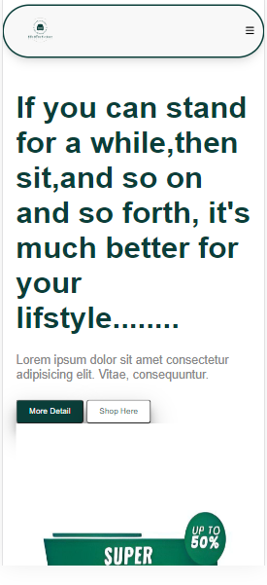

Figure(T1_4.8)

Mobile View of Item Page

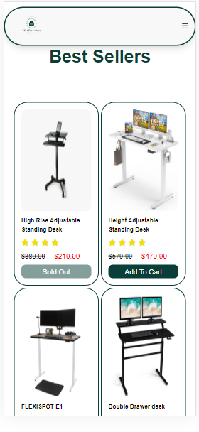

Figure(T1_4.9)

Mobile View of Item Page

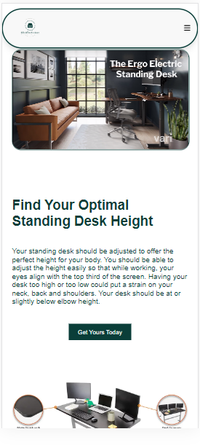

Figure(T1_4.10)

Mobile View of Item Page

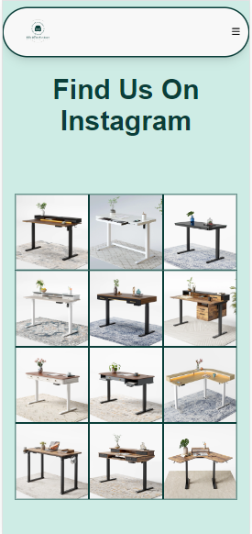

Figure(T1_4.11)

Mobile View of Item Page

Health Benefit Page

In “Health Benefit” Page, 80% of the sections are all about health benefits when using standing desk in daily life. “Review” section is also included. Navigation bar, “Subscription” section, and “Footer” section are always in all webpages.

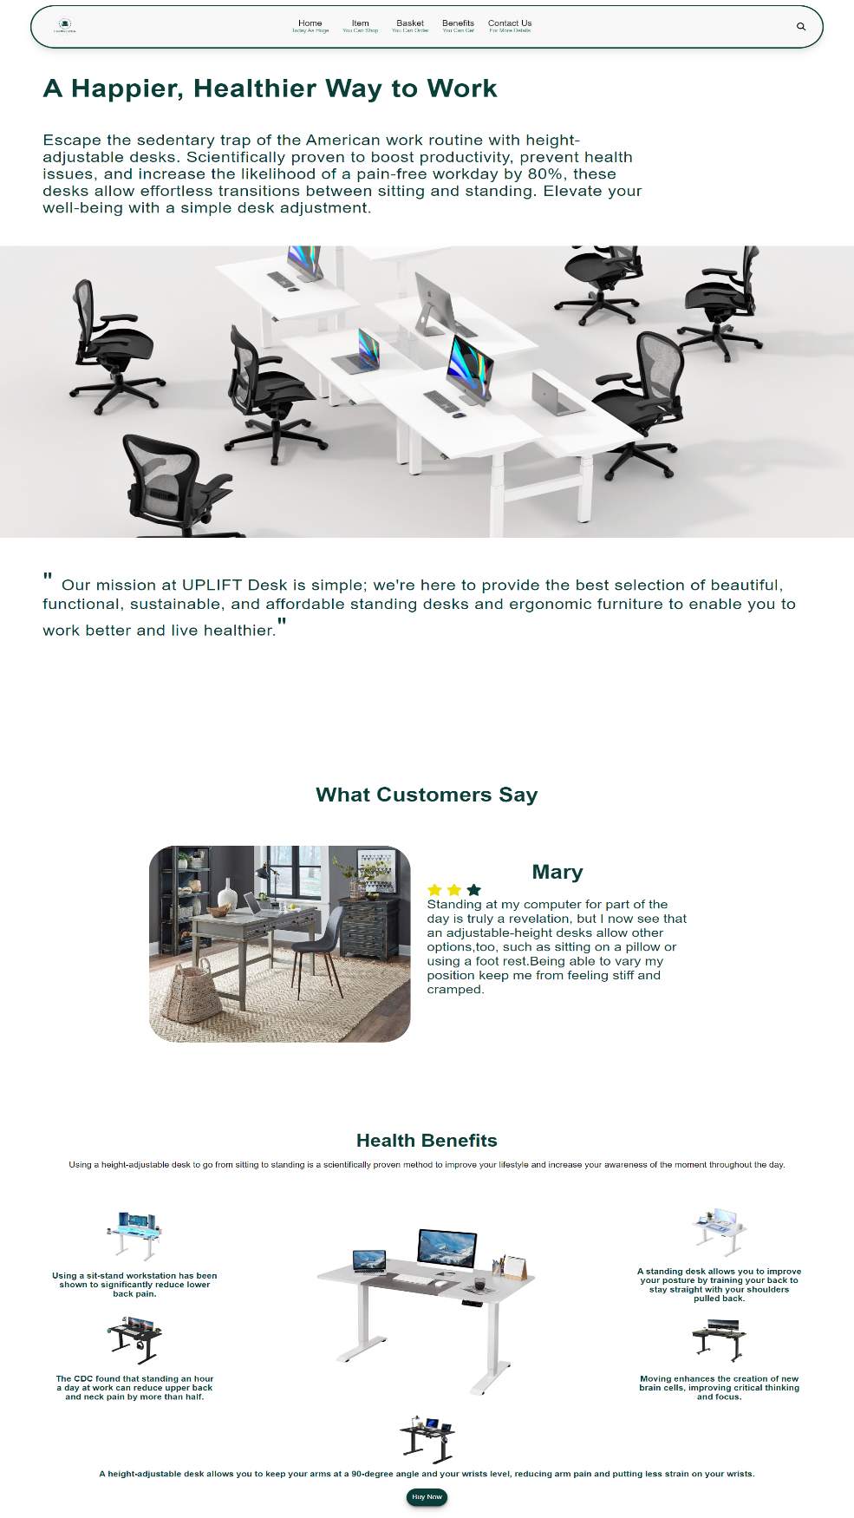

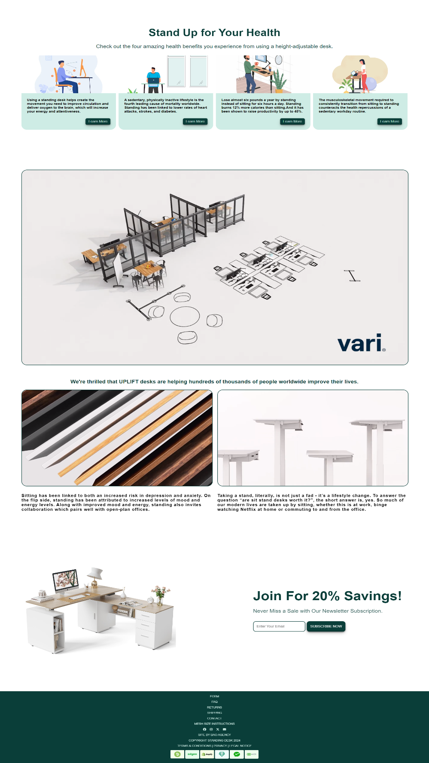\

Figure(T1_5.2)

Desktop View of Health Benefits Page

**Chrome View**

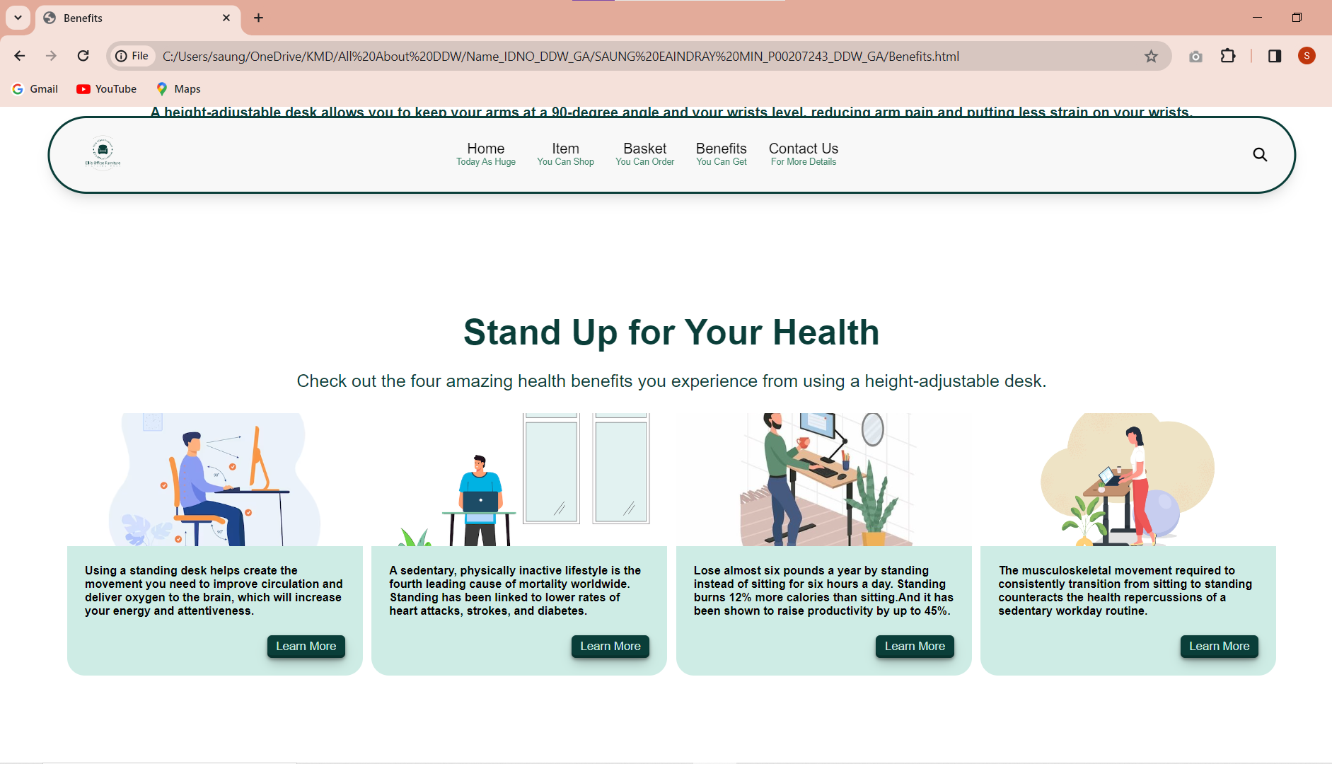

Desktop View of Health Benefits Page in Chrome Browser

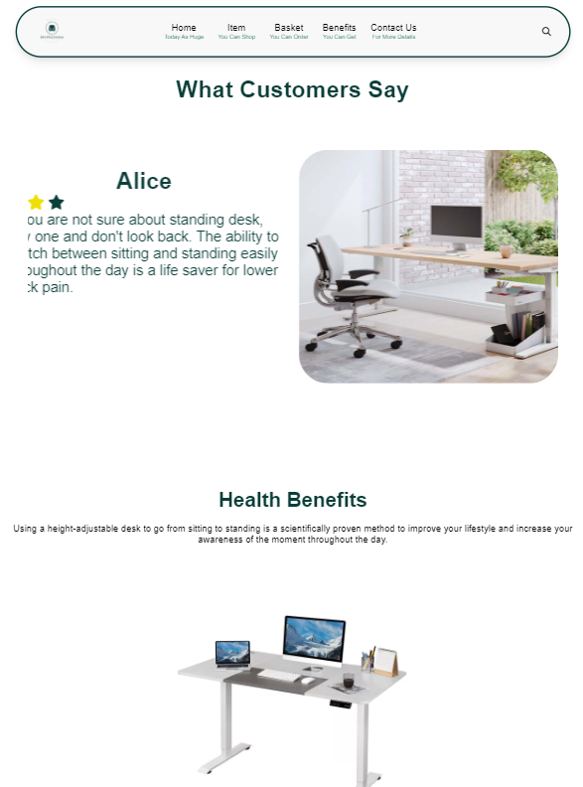

Figure(T1_5.3)

Tablet View of Health Benefits Page

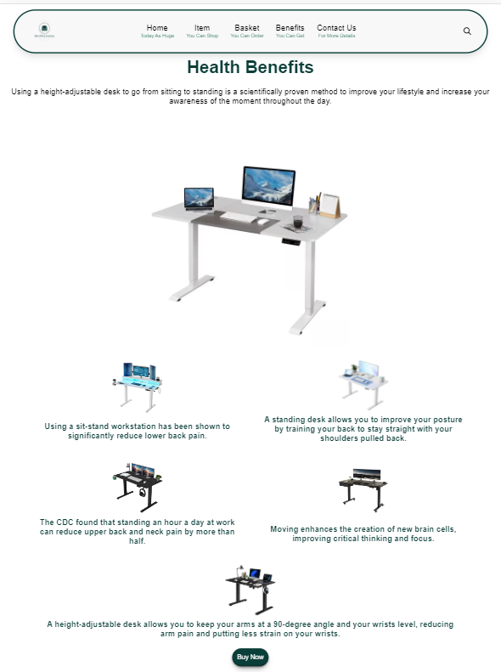

Figure(T1_5.4)

Tablet View of Health Benefits Page

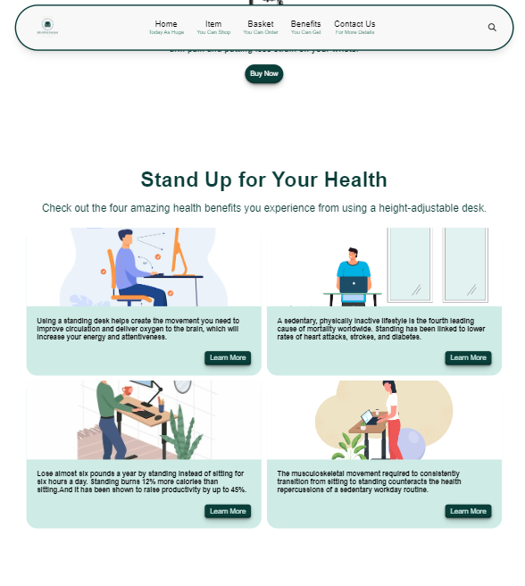

Figure(T1_5.5)

Tablet View of Health Benefits Page

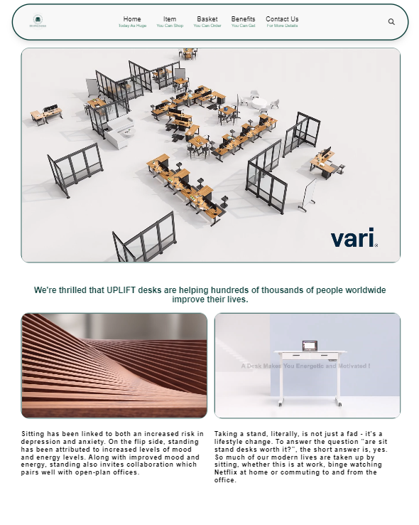

Figure(T1_5.6)

Tablet View of Health Benefits Page

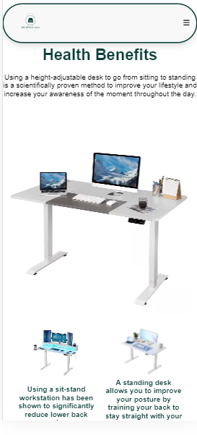

Figure(T1_5.7)

Mobile View of Health Benefits Page

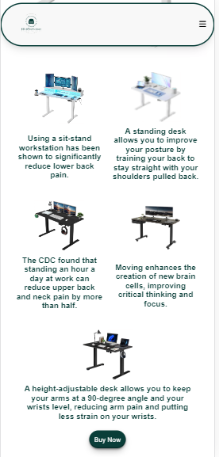

Figure(T1_5.8)

Mobile View of Health Benefits Page

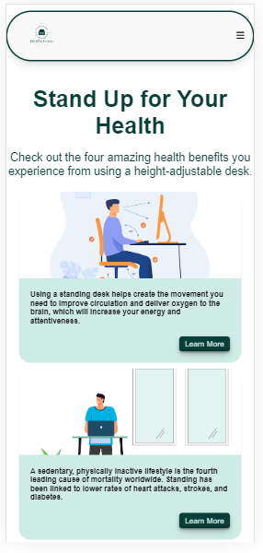

Figure(T1_5.9)

Mobile View of Health Benefits Page

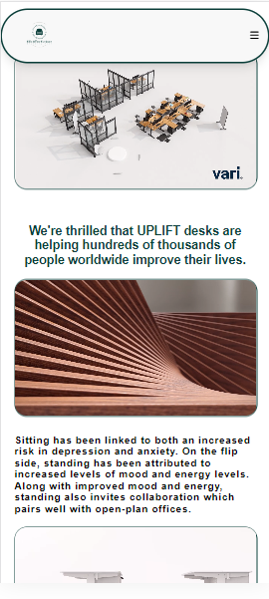

Figure(T1_5.10)

Mobile View of Health Benefits Page

**Basket Page**

In Basket Page, customer can shop different types of standing desk. And there are many payment methods.

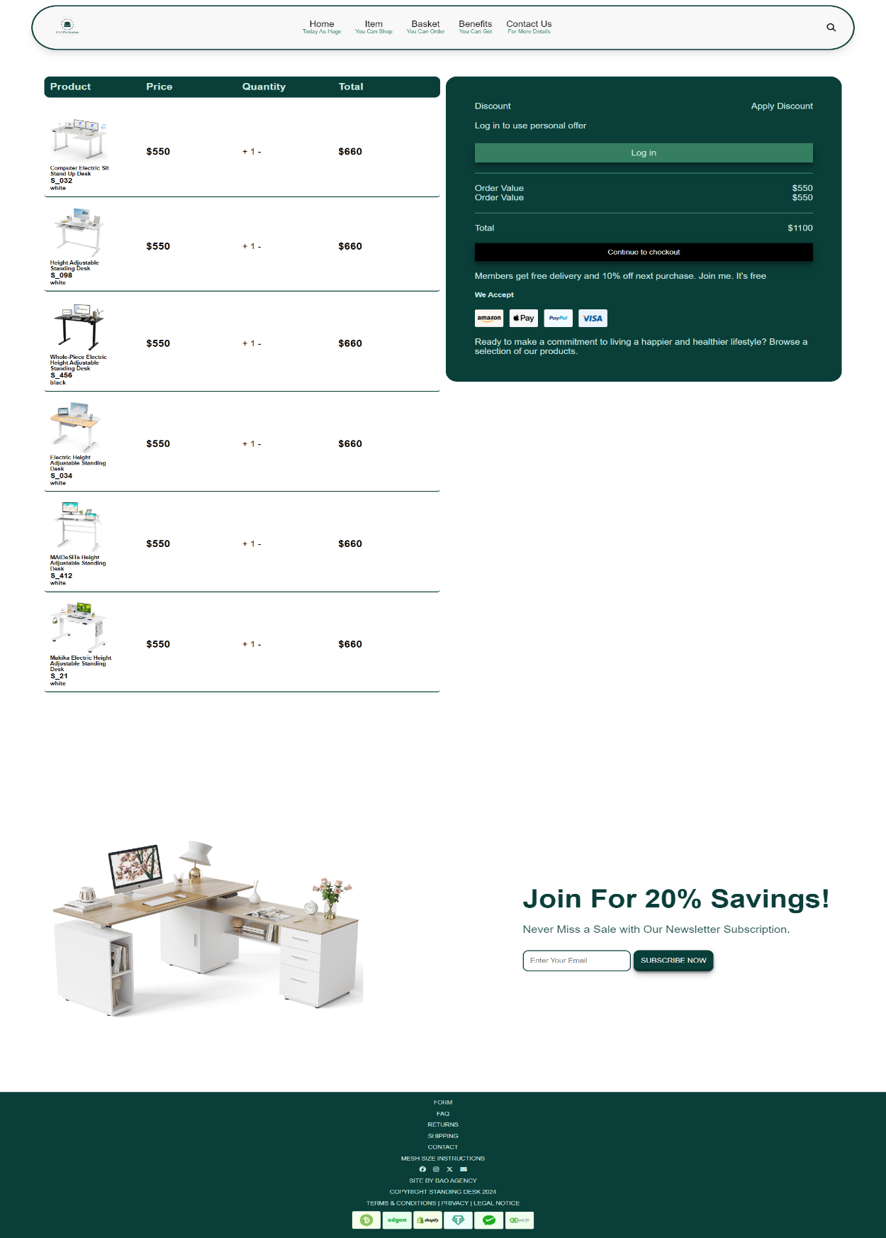

Figure(T1_6.1)

Desktop View of Basket Page

Chrome

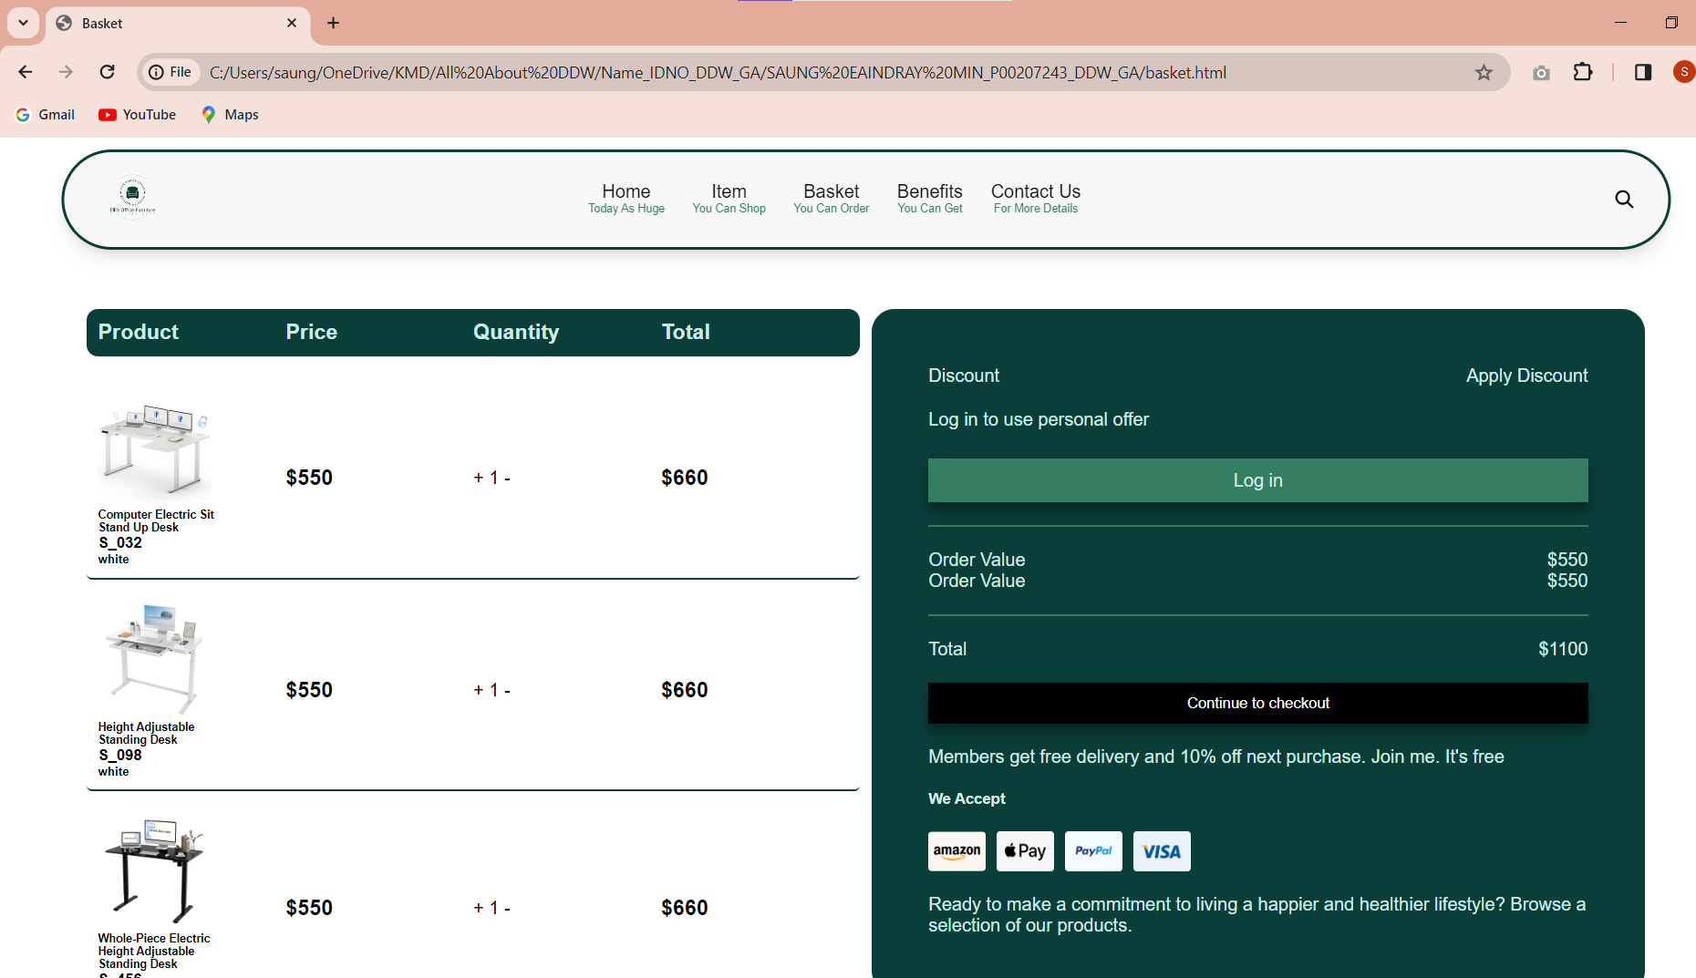

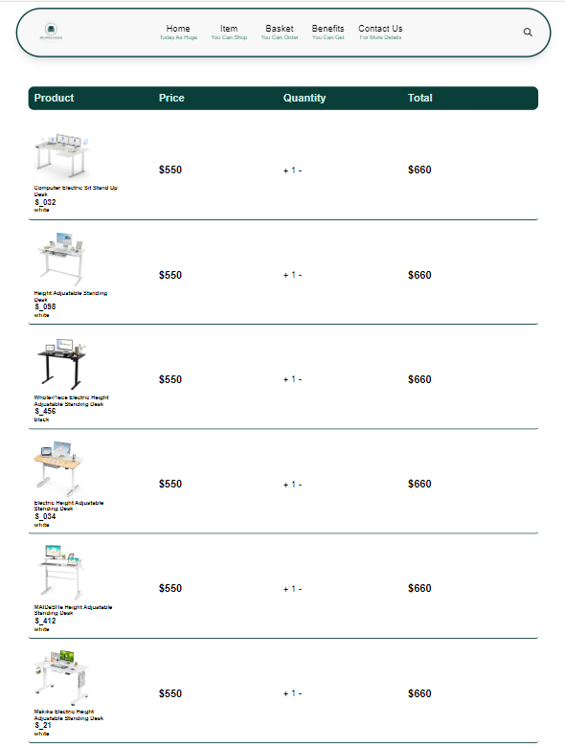

Figure(T1_6.2)

Tablet View of Basket Page

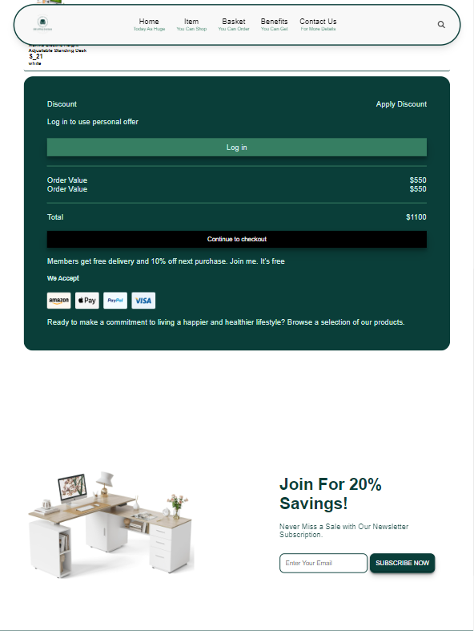

Figure(T1_6.3)

Tablet View of Basket Page

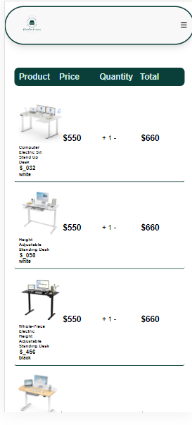

Figure(T1_6.4)

Mobile View of Basket Page

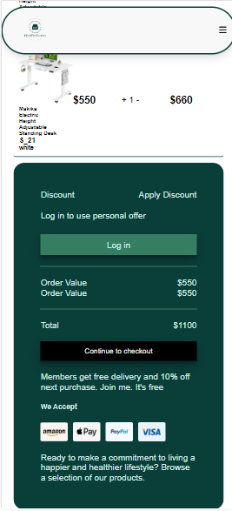

Figure(T1_6.5)

Mobile View of Basket Page

# **Task 2-CSS**

# **Task 2-CSS**

CSS, Cascading Style Sheets, is a language used to style elements written in markup languages like HTML. It separates the information from the website's visual design. Since HTML is the core of a website and CSS is responsible for its overall aesthetics, the two languages have a close relationship. (G, 2023).

## **External CSS**

.container {

width: 80%;

margin: auto;

}

:root {

--dark-color: black;

--silent-color: rgb(134, 134, 134);

--green-color: #367e62;

--darkgreen-color: #0a3e39;

--palegreen-color: #ceece5;

--teagreen-color: #d0f0c0;

}

body {

font-family: Arial, Helvetica, sans-serif;

/* background-color: var(--palegreen-color); */

/* overflow: hidden; */

}

* {

padding: 0;

margin: 0;

}

html {

scroll-behavior: smooth;

}

/* Start Nav CSS section */

nav {

width: 90%;

background-color: #f8f8f8;

display: flex;

justify-content: space-between;

align-items: center;

z-index: 99;

position: fixed;

top: 10px;

left: 50%;

transform: translateX(-50%);

padding: 15px 20px;

border-radius: 999px;

border: 3px solid var(--darkgreen-color);

box-shadow: rgba(0, 0, 0, 0.1) 0px 10px 15px -3px,

rgba(0, 0, 0, 0.05) 0px 4px 6px -2px;

animation: navani 1s ease-in-out;

}

.brandname img {

width: 80px;

}

.navbar {

gap: 0 20%;

list-style: none;

}

.navbar li {

display: inline-block;

text-align: center;

transition: 0.5s;

margin: 0 10px;

}

.navbar li:hover {

transform: translateY(-30%);

}

.nav-search {

display: none;

padding: 10px 20px;

border-radius: 999px;

outline: none;

border: 2px solid var(--green-color);

}

.lap-view {

max-width: 80px;

display: block;

transform: scaleX(0);

transition: all 0.5s;

}

.navbar a {

color: black;

text-decoration: none;

}

.navbar a p {

text-transform: capitalize;

color: var(--green-color);

font-size: 10px;

}

.hamburger-label {

display: none;

z-index: 2;

}

.hamburger {

display: none;

}

.hamburger-label input {

appearance: none;

pointer-events: none;

}

@keyframes navani {

0% {

transform: translate(-50%, -100px);

}

100% {

transform: translate(-50%, 0);

}

}

.search-btn {

cursor: pointer;

display: flex;

align-items: center;

gap: 10px;

border: none;

margin-right: 10px;

}

.search-btn:hover .lap-view {

transform: scaleX(1);

}

.dropdown {

position: relative;

display: inline-block;

}

.dropdown-content {

display: none;

min-width: max-content;

padding: 5px;

border-radius: 50px;

text-align: left;

position: absolute;

/* bottom: -25px; */

bottom: -100%;

left: -20px;

background-color: white;

z-index: 1;

}

.dropdown-content a {

font-size: 14px;

padding: 10px;

}

.dropdown:hover .dropdown-content {

display: block;

}

.dropdown-content a:hover {

color: var(--green-color);

transform: translateY(-30%);

}

/* End Nav CSS section */

/* Start Home Page CSS section */

.div-itemcover {

position: relative;

}

.div-itemcover img {

width: 100%;

height: 100%;

animation: itemcoverani 1s;

}

@keyframes itemcoverani {

0% {

opacity: 0;

transform: scale(0.8);

}

100% {

opacity: 1;

transform: scale(1);

}

}

.itemcover-overlay {

width: 100%;

height: 100%;

background-color: var(--darkgreen-color);

top: 0;

left: 0;

position: absolute;

opacity: 0.7;

}

.item-cover-word {

width: 90%;

text-align: center;

position: absolute;

top: 50%;

left: 50%;

transform: translate(-50%, -50%);

display: flex;

flex-direction: column;

justify-content: center;

align-items: center;

gap: 25px;

}

.item-cover-word h2 {

color: white;

font-size: 50px;

}

.item-cover-word p {

color: var(--palegreen-color);

font-size: xx-large;

}

.item-cover-word span {

background-color: var(--palegreen-color);

color: var(--darkgreen-color);

border: 2px solid var(--darkgreen-color);

border-radius: 20px;

padding: 20px;

}

.item-cover-word button {

background-color: var(--dark-color);

border: none;

border-radius: 20px;

padding: 10px 20px;

color: white;

transition: 0.5s;

box-shadow: rgba(0, 0, 0, 0.09) 0px 2px 1px, rgba(0, 0, 0, 0.09) 0px 4px 2px,

rgba(0, 0, 0, 0.09) 0px 8px 4px, rgba(0, 0, 0, 0.09) 0px 16px 8px,

rgba(0, 0, 0, 0.09) 0px 32px 16px;

}

.item-cover-word button:hover {

background-color: var(--palegreen-color);

color: var(--darkgreen-color);

transform: translateY(-30%);

}

/* Start Special Section */

.spoffer-container {

padding: 30px 0;

/* background-color: var(--palegreen-color); */

}

.spoffer-container .container {

display: grid;

grid-template-columns: repeat(2, 1fr);

border: 2px solid var(--darkgreen-color);

box-shadow: rgb(204, 219, 232) 3px 3px 6px 0px inset,

rgba(255, 255, 255, 0.5) -3px -3px 6px 1px inset;

transition: 0.5s;

}

.spoffer-container .container:hover {

background-color: var(--palegreen-color);

transform: translateY(-30%);

}

.spoffer-container .container .spoffer-left {

display: flex;

justify-content: center;

align-items: center;

}

.spoffer-container .container .spoffer-left h1 {

font-size: 45px;

}

.spoffer-container .container .spoffer-left p {

color: var(--darkgreen-color);

}

.spoffer-container .container .spoffer-right img {

width: 100%;

height: auto;

}

/* End Special Section */

.home-hb .home-div1 img {

width: 100%;

height: 400px;

border-radius: 18px;

}

.home-div1 {

display: grid;

grid-template-columns: repeat(2, 1fr);

gap: 80px;

margin: 200px 0;

margin-top: 100px;

}

.home-hb .home-div1 p {

margin-top: 30px;

line-height: 40px;

font-size: 20px;

color: var(--darkgreen-color);

margin-bottom: 30px;

}

.home-hb .home-div1 h1 {

color: var(--darkgreen-color);

font-size: 60px;

}

.home-div2 {

display: flex;

justify-content: center;

align-items: center;

gap: 80px;

margin-top: 200px;

padding: 50px;

margin-bottom: 50px;

}

.home-hb .home-div2 img {

width: 400px;

height: 400px;

border-radius: 18px;

}

.home-hb .home-div2 p {

margin-top: 30px;

line-height: 40px;

font-size: 20px;

color: var(--darkgreen-color);

margin-bottom: 30px;

}

.home-hb .home-div2 h1 {

color: var(--darkgreen-color);

font-size: 60px;

}

.home-div3 {

display: flex;

justify-content: center;

align-items: center;

margin-top: 200px;

gap: 35px;

}

.item-vd {

/* border: 2px solid var(--darkgreen-color); */

border-radius: 20px;

}

.itemvideo-container {

display: grid;

grid-template-columns: 1fr 1fr;

gap: 80px;

}

.itemvideo-left {

height: 70%;

display: flex;

justify-content: center;

align-items: center;

}

.itemvideo-left video {

width: 100%;

height: auto;

border-radius: 20px;

}

.itemvideo-right video {

width: 80%;

float: right;

margin-top: 50px;

}

.itemvideo-words {

display: flex;

justify-content: center;

align-items: center;

background-color: var(--palegreen-color);

flex-direction: column;

gap: 30px;

width: 100%;

/* height: 30%; */

padding: 30px 0;

border: 2px solid var(--darkgreen-color);

border-radius: 50px;

font-size: 18px;

letter-spacing: 1px;

line-height: 150%;

}

.itemvideo-words p {

width: 80%;

}

.itemvideo-words button {

background-color: var(--darkgreen-color);

border-radius: 20px;

padding: 12px;

color: white;

transition: 0.5s;

border: none;

}

.itemvideo-words button:hover {

background-color: white;

color: var(--darkgreen-color);

transform: translateY(-30%);

}

/* ! Start Item */

.itemContainer {

padding: 80px 0;

}

.itemContainer h2 {

text-align: center;

margin-top: 90px;

margin-bottom: 60px;

font-size: 30px;

}

.itemContainer .container {

display: grid;

grid-template-columns: repeat(4, 1fr);

gap: 3%;

}

.itemContainer .container .item-card {

width: 100%;

background-color: white;

padding: 10px;

box-shadow: rgba(0, 0, 0, 0.1) 0px 10px 15px -3px,

rgba(0, 0, 0, 0.05) 0px 4px 6px -2px;

}

.itemContainer .container .item-card img {

width: 100%;

height: 370px;

}

.itemContainer .container .item-card h1 {

font-size: 20px;

}

.itemContainer .container .item-card .item-stars {

display: flex;

gap: 5px;

margin: 10px 0;

}

.itemContainer .container .item-card .item-stars i.fillstar {

color: yellow;

}

.item-card .item-bottom {

display: flex;

align-items: center;

justify-content: space-between;

}

.item-card button {

cursor: pointer;

color: #ffffff;

background-color: var(--darkgreen-color);

display: flex;

justify-content: center;

align-items: center;

gap: 0 10px;

padding: 10px 20px;

border-radius: 40px;

border: none;

font-weight: bold;

transform: scaleX(1);

position: relative;

transition: all 0.5s;

}

.item-card button::before {

content: "Add To Cart";

width: max-content;

height: 100%;

display: flex;

justify-content: center;

align-items: center;

background-color: var(--darkgreen-color);

left: -100%;

border-radius: 30px 0 0 30px;

border-radius: 30px;

padding-left: 10px;

position: absolute;

z-index: 0;

opacity: 0;

transform: translateX(10px);

transition: all 0.5s;

}

.item-card button:hover {

background-color: #efdf04;

}

.item-card button:hover::before {

opacity: 1;

transform: translateX(-18%);

background-color: #efdf04;

}

.item-card button i {

font-size: 18px;

}

.item-price span {

color: red;

font-size: 20px;

}

/* ! End Item */

.div-shipping {

display: grid;

grid-template-columns: 1fr 1fr 1fr;

color: white;

gap: 40px;

line-height: 30px;

}

.shipping-icon {

display: flex;

gap: 20px;

align-items: center;

margin-bottom: 30px;

}

.shipping {

background-color: var(--darkgreen-color);

padding: 120px;

/* border-radius: 50px; */

/* margin-left: 30px;

margin-right: 30px; */

}

.modal {

pointer-events: none;

opacity: 0;

width: 100%;

height: 100%;

display: flex;

justify-content: center;

align-items: center;

background: rgba(255, 255, 255, 0.2);

border-radius: 16px;

box-shadow: 0 4px 30px rgba(0, 0, 0, 0.1);

-webkit-backdrop-filter: blur(5px);

backdrop-filter: blur(5px);

border: 1px solid rgba(255, 255, 255, 0.3);

top: 0;

left: 0;

position: fixed;

transition: all 0.3s ease-in-out;

}

.modal-container {

width: 60%;

display: grid;

grid-template-columns: 1fr 1fr;

background-color: #ffffff;

box-shadow: rgba(17, 12, 46, 0.15) 0px 48px 100px 0px;

padding: 30px;

border-radius: 30px;

}

.modal-left {

width: 80%;

display: flex;

flex-direction: column;

justify-content: center;

gap: 10px;

}

.modal-left input {

padding: 15px;

border: 2px solid #0a3e39;

}

.modal-left button {

cursor: pointer;

padding: 15px;

font-weight: bold;

border: 2px solid #0a3e39;

background-color: transparent;

}

.modal-right {

width: 100%;

height: 300px;

background-image: url("../images/modalpopup.png");

background-position: bottom;

background-size: cover;

border: 2px solid var(--darkgreen-color);

}

.modal-btn {

cursor: pointer;

position: fixed;

top: 15%;

right: 5%;

z-index: 99;

border-radius: 999px;

}

.modal-btn img {

width: 60px;

height: 60px;

border-radius: 999px;

}

.open-close-btn {

display: none;

}

#open-close-btn:checked ~ .modal {

opacity: 1;

pointer-events: all;

}

/* End Home Page CSS section */

/* Start item Page CSS section */

.hero-container {

margin-top: 200px;

display: flex;

justify-content: center;

align-items: center;

}

.hero-layout {

display: grid;

grid-template-columns: repeat(2, 1fr);

transform: translateY(0%);

animation: heroani 1s ease-in-out;

}

@keyframes heroani {

0% {

opacity: 0;

transform: translateY(100%);

}

100% {

opacity: 1;

transform: translateY(0%);

}

}

.hero-layout h1 {

font-size: 50px;

color: var(--darkgreen-color);

}

.hero-layout p {

font-size: 20px;

color: var(--silent-color);

margin: 30px 0;

}

.hero-layout img {

width: 500px;

height: 500px;

}

.hero-layout {

margin-top: 150px;

}

.hero-btn1 {

background-color: var(--darkgreen-color);

color: white;

padding: 10px 20px;

border-radius: 5px;

transition: 0.5s;

box-shadow: rgba(0, 0, 0, 0.3) 0px 19px 38px,

rgba(0, 0, 0, 0.22) 0px 15px 12px;

}

.hero-btn1:hover {

background-color: var(--palegreen-color);

color: var(--darkgreen-color);

transform: translateY(-20%);

}

.hero-btn2 {

background-color: white;

color: var(--darkgreen-color);

padding: 10px 20px;

border-radius: 5px;

transition: 0.5s;

box-shadow: rgba(0, 0, 0, 0.3) 0px 19px 38px,

rgba(0, 0, 0, 0.22) 0px 15px 12px;

}

.hero-btn2:hover {

background-color: var(--palegreen-color);

color: var(--dark-color);

transform: translateY(-20%);

}

/* Start Best Seller Section */

.bestcart-container {

width: 90%;

display: grid;

grid-template-columns: repeat(4, 1fr);

gap: 30px;

margin: auto;

}

.bestseller-container h1 {

text-align: center;

margin-top: 150px;

font-size: 40px;

margin-bottom: 80px;

color: var(--darkgreen-color);

}

.bc-card {

border-radius: 30px;

border: 2px solid var(--darkgreen-color);

padding: 20px;

line-height: 20px;

display: grid;

gap: 10px;

}

.bc-card img {

width: 100%;

height: 230px;

border-radius: 15px;

}

.soldout {

cursor: not-allowed;

text-decoration: none;

border-radius: 10px;

background-color: var(--darkgreen-color);

padding: 5px;

color: white;

text-align: center;

opacity: 0.5;

}

.instock {

text-decoration: none;

border-radius: 10px;

background-color: var(--darkgreen-color);

padding: 5px;

color: white;

text-align: center;

transition: 0.5s;

}

.instock:hover {

background-color: var(--palegreen-color);

color: var(--darkgreen-color);

transform: translateY(-30%);

}

.bc-card del {

font-size: 15px;

color: black;

margin-right: 20px;

}

.bc-card p {

color: red;

font-size: 20px;

}

.bc-card i {

color: #efdf04;

}

/* End Best Seller Section */

.div-quote .quote h2 {

font: bold;

font-size: 30px;

color: var(--darkgreen-color);

}

.quote {

width: 80%;

}

.item-vd {

width: 100%;

}

.quote-img img {

width: 100%;

}

.div-quote p,

.setup p {

color: var(--darkgreen-color);

}

.div-quote button,

.setup button,

.div-category2 button {

width: max-content;

padding: 10px 20px;

border: none;

margin: auto;

background-color: var(--darkgreen-color);

color: white;

transition: 0.5s;

}

.div-quote button:hover,

.setup button:hover,

.div-category2 button:hover {

background-color: var(--palegreen-color);

color: var(--darkgreen-color);

transform: translateY(-30%);

}

.item-quote {

margin-top: 250px;

background-color: white;

}

.div-quote video {

border: 2px solid var(--darkgreen-color);

border-radius: 20px;

}

.div-quote {

display: flex;

justify-content: center;

align-items: center;

gap: 100px;

padding: 30px 0;

}

.div-quote .quote {

display: grid;

gap: 40px;

}

.div-setup {

display: flex;

justify-content: space-between;

align-items: center;

gap: 100px;

}

.div-setup img {

width: 600px;

height: 600px;

}

.div-setup h2 {

color: var(--darkgreen-color);

font: bold;

font-size: 30px;

}

.setup {

display: grid;

gap: 40px;

}

.div-category {

display: grid;

grid-template-columns: 1fr 1fr;

margin-top: 50px;

}

.div-category2 {

width: 100%;

height: 500px;

position: relative;

}

.item-category-words {

position: absolute;

top: 70%;

left: 10%;

color: white;

font-size: 25px;

font: bold;

z-index: 1;

}

.item-category-words h2 {

margin-bottom: 15px;

}

.div-category img {

width: 100%;

height: 100%;

}

.itemcategory-overlay {

width: 100%;

height: 100%;

background-color: var(--darkgreen-color);

top: 0;

left: 0;

position: absolute;

opacity: 0.3;

}

.item-category h1 {

color: var(--darkgreen-color);

font-size: 300%;

font: bold;

text-align: center;

}

.item-category span {

color: var(--darkgreen-color);

font-size: 100%;

text-align: center;

margin-top: 15px;

display: block;

line-height: 20px;

opacity: 0.7;

}

.item-category {

background-color: var(--palegreen-color);

padding: 150px 0;

}

.item {

background-color: white;

padding: 200px 0;

}

.div-item {

display: grid;

grid-template-columns: repeat(4, 1fr);

gap: 30px;

}

.div-item .item-card {

width: 100%;

/* height: 300px; */

display: grid;

gap: 10px;

background-color: #ffffff;

box-shadow: 2px 2px 5px var(--darkgreen-color);

border-radius: 10px;

padding: 10px;

position: relative;

}

.div-item .item-card img {

width: 100%;

border-radius: 10px;

height: 300px;

}

.star-container i.fullstar {

color: #efdf04;

}

.item-bot {

display: flex;

justify-content: space-between;

align-items: center;

}

.item-bot p {

font-size: 18px;

color: red;

}

.item-bot del {

font-size: 14px;

margin-right: 8px;

color: black;

}

.item-card button {

color: #ffffff;

background-color: var(--darkgreen-color);

padding: 10px 13px;

border-radius: 40px;

}

.item-card button i {

font-size: 18px;

}

.item-card h2 {

font-size: 20px;

}

.item-dis {

width: 40px;

height: 40px;

display: flex;

justify-content: center;

align-items: center;

color: #ffffff;

background-color: var(--green-color);

border-radius: 50px;

font-size: 14px;

top: 5px;

right: 5px;

position: absolute;

}

.item-seemore {

background-color: var(--palegreen-color);

padding: 60px 0;

}

.item-seemore .container {

display: grid;

grid-template-columns: repeat(6, 1fr);

margin-top: 100px;

margin-bottom: 100px;

}

.item-seemore img {

width: 100%;

height: 100%;

transition: all 0.3s;

}

.seemore-card {

border: 2px solid var(--darkgreen-color);

overflow: hidden;

position: relative;

z-index: 2;

}

.seemore-card:hover img {

transform: scale(1.2);

}

.item-seemore h1 {

text-align: center;

color: var(--darkgreen-color);

font-size: 100px;

font: bold;

margin-top: 100px;

}

.itemseemore-overlay {

width: 100%;

height: 100%;

background-color: var(--darkgreen-color);

top: 0;

left: 0;

position: absolute;

z-index: 99;

opacity: 0;

}

.seemore-card:nth-of-type(1):hover .itemseemore-overlay:nth-of-type(1) {

opacity: 0.5;

}

.seemore-card:nth-of-type(2):hover .ovl2 {

opacity: 0.5;

}

.seemore-card:nth-of-type(3):hover .ovl3 {

opacity: 0.5;

}

.seemore-card:nth-of-type(4):hover .ovl4 {

opacity: 0.5;

}

.seemore-card:nth-of-type(5):hover .ovl5 {

opacity: 0.5;

}

.seemore-card:nth-of-type(6):hover .ovl6 {

opacity: 0.5;

}

.seemore-card:nth-of-type(7):hover .ovl7 {

opacity: 0.5;

}

.seemore-card:nth-of-type(8):hover .ovl8 {

opacity: 0.5;

}

.seemore-card:nth-of-type(9):hover .ovl9 {

opacity: 0.5;

}

.seemore-card:nth-of-type(10):hover .ovl10 {

opacity: 0.5;

}

.seemore-card:nth-of-type(11):hover .ovl11 {

opacity: 0.5;

}

.seemore-card:nth-of-type(12):hover .ovl12 {

opacity: 0.5;

}

.item-seemore-word {

position: absolute;

top: 40%;

left: 30%;

display: grid;

grid-template-columns: 1fr;

gap: 20px;

}

.item-seemore-word button {

border: none;

background-color: var(--darkgreen-color);

color: white;

font-size: 20px;

}

.item-seemore i {

color: white;

font-size: xx-large;

text-align: center;

}

.item-seemore h1 {

font-size: 300%;

}

/* End item Page CSS section */

/* Start item details CSS section */

.itmdet-container {

margin: 100px 0;

}

.itmdet-container .container {

display: grid;

grid-template-columns: repeat(2, 1fr);

gap: 20px;

}

.itmdet-container .container .itmdet-left {

width: 100%;

display: flex;

flex-direction: column;

justify-content: center;

align-items: center;

}

.itmdet-container .container .itmdet-left .itmdet-img {

width: 80%;

}

.itmdet-container .container .itmdet-left .itmdet-img img {

width: 100%;

height: 100%;

}

.itmdet-container .container .itmdet-left .itmdet-imgs {

display: grid;

grid-template-columns: repeat(3, 1fr);

gap: 50px;

margin: 20px 0;

}

.itmdet-container .container .itmdet-left .itmdet-imgs img {

width: 100%;

height: 70px;

}

.itmdet-container .container .itmdet-right {

width: 100%;

display: flex;

flex-direction: column;

gap: 20px;

}

.itmdet-right h1 {

font-size: 35px;

color: var(--darkgreen-color);

}

.itmdet-dollar {

color: red;

font-size: 30px;

}

.itmdet-right .itmdet-dollar {

font-weight: bold;

}

.itmdet-right .itmdet-para {

letter-spacing: 1px;

color: var(--darkgreen-color);

}

.itmdet-right .itmdet-quan {

display: flex;

justify-content: space-between;

font-weight: bold;

}

.itmdet-right .itmdet-quan span {

font-size: 18px;

}

.itmdet-right a {

text-decoration: none;

/* border: 2px solid var(--darkgreen-color); */

text-align: center;

padding: 10px;

margin-top: 30px;

color: var(--darkgreen-color);

transition: 0.5s;

box-shadow: rgba(0, 0, 0, 0.4) 0px 2px 4px,

rgba(0, 0, 0, 0.3) 0px 7px 13px -3px, rgba(0, 0, 0, 0.2) 0px -3px 0px inset;

}

.itmdet-right a:hover {

background-color: var(--darkgreen-color);

color: white;

transform: translateY(-30%);

}

.itmdet-quan input {

border: none;

width: 50px;

font-size: 20px;

}

.accordion-card {

display: flex;

justify-content: space-between;

align-items: center;

margin: 10px 0;

}

.accordion-container {

margin-bottom: 180px;

}

.itemdetails-videoDiv {

display: grid;

grid-template-columns: 1fr 1fr;

gap: 60px;

}

embed {

width: 100%;

height: 375px;

}

.itemdetails-videoWords h1 {

margin-bottom: 50px;

word-spacing: 3px;

}

.itemdetails-videoWords span {

color: var(--dark-color);

font-weight: bold;

word-spacing: 5px;

line-height: 30px;

}

/* End item details CSS section */

/* Start Basket Page CSS section */

.basket-container {

margin: 150px 0;

}

.basket-container .container {

display: grid;

grid-template-columns: 1fr 1fr;

gap: 10px;

overflow: hidden;

position: relative;

}

.basket-left {

display: grid;

gap: 10px;

}

.basket-nav {

display: grid;

grid-template-columns: repeat(4, 1fr);

background-color: var(--darkgreen-color);

padding: 10px;

color: var(--palegreen-color);

border-radius: 10px;

margin-bottom: 10px;

}

.basket-card {

display: grid;

grid-template-columns: repeat(4, 1fr);

align-items: center;

padding: 10px;

border-radius: 5px;

border-bottom: 2px solid var(--darkgreen-color);

/* background-color: var(--palegreen-color); */

}

.basket-card .productinfo img {

height: 100px;

}

.basket-right {

height: fit-content;

color: var(--palegreen-color);

background-color: var(--darkgreen-color);

padding: 50px;

gap: 10px;

border-radius: 20px;

position: sticky;

top: 0px;

right: 0;

}

.basket-right-container {

width: 100%;

display: grid;

gap: 20px;

}

.basket-flex {

display: flex;

justify-content: space-between;

align-self: center;

}

.basket-login {

display: grid;

gap: 5px;

}

.basket-login .login-btn {

color: var(--palegreen-color);

background-color: var(--green-color);

margin-top: 20px;

text-align: center;

text-decoration: none;

padding: 10px;

transition: 0.5s;

box-shadow: rgba(0, 0, 0, 0.19) 0px 10px 20px, rgba(0, 0, 0, 0.23) 0px 6px 6px;

}

.basket-login .login-btn:hover {

background-color: white;

color: var(--darkgreen-color);

transform: translateY(-20%);

}

.order-container {

padding: 20px 0;

border-top: 2px solid var(--green-color);

border-bottom: 2px solid var(--green-color);

}

.basket-checkout {

padding: 10px 0;

color: white;

background-color: black;

border: none;

transition: 0.5s;

box-shadow: rgba(0, 0, 0, 0.19) 0px 10px 20px, rgba(0, 0, 0, 0.23) 0px 6px 6px;

}

.basket-checkout:hover {

background-color: white;

color: var(--dark-color);

transform: translateY(-30%);

}

.payment {

display: flex;

flex-wrap: wrap;

gap: 10px;

}

.payment img {

width: 50px;

height: auto;

}

.productinfo h4 {

font-size: 10px;

width: 70%;

}

/* End Basket Page CSS section */

/* Start Benefit Page CSS setion */

.item-review h1 {

padding: 80px;

font-size: 40px;

color: var(--darkgreen-color);

text-align: center;

}

.item-review img {

width: 100%;

height: auto;

}

.item-review {

margin-bottom: 100px;

}

.item-review .container {

display: flex;

justify-content: center;

align-items: center;

}

.div-review {

width: 100%;

/* height: 100%; */

display: flex;

justify-content: center;

align-items: center;

background-color: yellow;

gap: 20px;

/* margin-bottom: 200px; */

width: 80%;

}

.carousel {

width: 1000px;

height: auto;

display: flex;

overflow: hidden;

border-radius: 50px;

}

.carousel .review-card {

width: 1000px;

height: 100%;

display: flex;

transform: translateX(0);

animation: carouselani 20s ease-out infinite;

}

.carousel .review-card .review-img {

width: 500px;

height: 400px;

}

.carousel .review-card img {

width: 100%;

height: 100%;

border-radius: 50px;

}

.carousel .review-card .review-info {

color: var(--darkgreen-color);

background-color: white;

width: 500px;

padding: 30px;

border-radius: 50px;

font-size: 25px;

}

.star-container i.fullstar {

color: #efdf04;

}

.carousel .review-card .review-info h1 {

color: var(--darkgreen-color);

font: bold;

padding: 0;

}

@keyframes carouselani {

0% {

transform: translateX(0%);

}

25% {

transform: translateX(-100%);

}

50% {

transform: translateX(-200%);

}

75% {

transform: translateX(-100%);

}

100% {

transform: translateX(0%);

}

}

/* Start Health Benefit Section */

.healthContainer {

padding: 150px 0;

}

.healthContainer .container h1 {

width: 80%;

font-size: 50px;

letter-spacing: 1px;

color: var(--darkgreen-color);

}

.healthContainer .container p {

width: 80%;

color: var(--darkgreen-color);

font-size: 30px;

margin: 60px 0;

letter-spacing: 1px;

}

.benefit-quote span {

font-size: 50px;

}

.healthContainer .health-image {

width: 100%;

height: 80vh;

background-image: url(../images/benefit\ cover.webp);

background-position: center;

background-size: cover;

background-attachment: fixed;

}

.healthContainer .container p:nth-child(1) {

width: 100%;

}

/* End Health Benefit Section */

/* Start Advantage Section */

.advContainer {

text-align: center;

padding: 80px 0;

}

.advContainer h1 {

font-size: 35px;

margin-bottom: 20px;

color: var(--darkgreen-color);

}

.advContainer .container {

display: grid;

grid-template-columns: repeat(4, 1fr);

grid-gap: 20px;

margin-top: 80px;

}

.advContainer .container div {

width: 100%;

/* height: 200px; */

}

.advContainer .container .advCard {

display: flex;

flex-direction: column;

justify-content: center;

align-items: center;

gap: 5%;

}

.advContainer .container .advCard p {

margin: 10px 0;

width: 90%;

color: var(--darkgreen-color);

font-weight: bolder;

}

.advContainer .container div.item-mid {

grid-column: span 2;

grid-row: span 2;

height: 100%;

}

.advCard img {

height: 100px;

width: 100px;

transition: 0.5s;

}

.advCard img:hover {

transform: translateY(-10%);

}

.item-mid img {

width: 400px;

height: 400px;

}

.advContainer .container div.item-last {

grid-column: span 4;

}

.item-last button {

margin-top: 10px;

border: none;

padding: 10px;

color: white;

border-radius: 20px;

background-color: var(--darkgreen-color);

transition: 0.5s;

box-shadow: rgba(0, 0, 0, 0.4) 0px 2px 4px,

rgba(0, 0, 0, 0.3) 0px 7px 13px -3px, rgba(0, 0, 0, 0.2) 0px -3px 0px inset;

}

.item-last button:hover {

background-color: var(--palegreen-color);

color: var(--darkgreen-color);

transform: translateY(-30%);

}

/* End Advantage Section */

/* Start Use Section */

.useContainer {

text-align: center;

padding: 80px 0;

/* background-color: #d1e3cd; */

}

.useContainer h1 {

margin-bottom: 20px;

font-size: 40px;

color: var(--darkgreen-color);

}

.useContainer p {

margin-bottom: 25px;

color: var(--darkgreen-color);

font-size: 20px;

}

.useContainer img {

width: 100px;

height: 100px;

}

.useContainer .container {

display: grid;

grid-template-columns: repeat(4, 1fr);

gap: 10px;

}

.useContainer .container .use-card {

background-color: var(--palegreen-color);

}

.useContainer .container .use-card .use-img {

background-size: cover;

background-position: center;

height: 150px;

}

.useContainer .container .use-card .use-img.use1 {

background-image: url("../images/use1.jpg");

}

.useContainer .container .use-card .use-img.use2 {

background-image: url("../images/use2.png");

}

.useContainer .container .use-card .use-img.use3 {

background-image: url("../images/use3.jpg");

}

.useContainer .container .use-card .use-img.use4 {

background-image: url("../images/use4.png");

}

.useContainer .container .use-card {

border-radius: 20px;

}

.useContainer .container .use-card h4 {

font-size: 13px;

text-align: left;

padding: 20px;

}

.useContainer .container .use-card button {

float: right;

padding: 5px 10px;

margin-bottom: 20px;

margin-right: 20px;

color: var(--palegreen-color);

background-color: var(--darkgreen-color);

border-radius: 5px;

border: none;

transition: 0.5s;

box-shadow: rgba(0, 0, 0, 0.4) 0px 2px 4px,

rgba(0, 0, 0, 0.3) 0px 7px 13px -3px, rgba(0, 0, 0, 0.2) 0px -3px 0px inset;

}

.useContainer .container .use-card button:hover {

background-color: white;

color: var(--darkgreen-color);

transform: translateY(-30%);

}

/* End Use Section */

/* Start Benefit Video Section */

.benVdoContainer {

padding: 80px 0;

}

.benVdo {

width: 100%;

border-radius: 20px;

border: 2px solid var(--darkgreen-color);

}

.benvdoCardContainer {

display: grid;

grid-template-columns: repeat(2, 1fr);

gap: 20px;

}

.benVdoContainer .container h1 {

margin-bottom: 20px;

margin-top: 50px;

color: var(--darkgreen-color);

font-size: 20px;

text-align: center;

}

.benvdoCard {

width: 100%;

}

.benvdoCard video {

width: 100%;

border-radius: 20px;

border: 2px solid var(--darkgreen-color);

}

.benvdoCard .letter {

margin-top: 24px;

font-weight: bolder;

letter-spacing: 1px;

}

/* End Benefit Video Section */

/* End Benefit Page CSS section */

/* Start Contact Us Page section */

.container {

margin: auto;

width: 90%;

}

@keyframes heroani {

0% {

opacity: 0;

transform: translateY(100%);

}

100% {

opacity: 1;

transform: translateY(0%);

}

}

h1 {

color: var(--darkgreen-color);

font-size: 23px;

}

.contact-container {

height: 100vh;

display: flex;

justify-content: center;

align-items: center;

transform: translateY(0%);

animation: heroani 1s ease-in-out;

}

.contact-container .container {

background-color: var(--palegreen);

border-radius: 50px;

padding: 20px;

border: 3px var(--darkgreen-color) solid;

}

.heading {

display: flex;

justify-content: center;

align-items: center;

gap: 3px;

font-family: "Adamina", serif;

}

.contactform {

display: flex;

gap: 40px;

background-color: var(--palegreen);

border-radius: 30px;

padding: 50px;

margin: 40px;

}

.contactform input {

border: none;

/* margin: none; */

border-bottom: 3px black solid;

margin: 7px;

border-radius: 10px;

padding: 7px 5px;

outline: none;

border: 2px solid var(--darkgreen-color);

/* opacity: 0.8; */

}

textarea {

resize: none;

height: 50px;

width: 100%;

margin: 7px;

box-sizing: border-box;

background-color: white;

border: 2px var(--darkgreen-color) solid;

padding: 5px 5px;

outline: none;

border-radius: 10px;

color: white;

}

.btnsubmit:hover {

background-color: var(--palegreen-color);

color: var(--darkgreen-color);

transform: translateY(-30%);

}

.btnsubmit {

transition: 0.5s;

color: white;

background-color: var(--darkgreen-color);

cursor: pointer;

padding: 5px 30px;

}

.info {

width: 30%;

display: grid;

margin: 10px;

color: var(--darkgreen-color);

}

.facebook,

.YouTube,

.Email,

.Wechat {

display: flex;

align-items: center;

gap: 5px;

margin: 20px;

border: 2px var(--green-color) solid;

border-radius: 5px;

padding: 5px;

}

.quicklinks {

margin: 0 10px;

padding: 0 5px;

color: var(--darkgreen-color);

}

.quicklinks p {

margin-top: 10px;

}

/* End Contact Us Page section */

/* Start Footer Section */

footer {

padding: 15px 0;

display: grid;

gap: 10px;

text-align: center;

color: var(--palegreen-color);

background-color: var(--darkgreen-color);

font-size: 11px;

}

footer i {

margin: 0 5px;

}

footer p {

text-transform: uppercase;

}

footer img {

width: 50px;

height: auto;

}

.home-saving {

display: grid;

grid-template-columns: 1fr 1fr;

align-items: center;

padding: 40px 0;

gap: 20%;

animation: adujust linear both;

}

@keyframes adujust {

0% {

object-position: 100% 0;

}

100% {

object-position: 0 0;

}

}

.home-saving img {

width: 100%;

height: auto;

background-attachment: fixed;

}

.homesaving-words {

display: grid;

grid-template-columns: 1fr;

gap: 20px;

}

.homesaving-words h1 {

font-size: 50px;

color: var(--darkgreen-color);

}

.homesaving-words span {

color: var(--darkgreen-color);

opacity: 0.9;

font-size: 20px;

}

.home-saving button {

background-color: var(--darkgreen-color);

border: 2px solid var(--darkgreen-color);

color: white;

border-radius: 10px;

padding: 11px;

transition: 0.5s;

margin: 10px 0;

box-shadow: rgba(0, 0, 0, 0.4) 0px 2px 4px,

rgba(0, 0, 0, 0.3) 0px 7px 13px -3px, rgba(0, 0, 0, 0.2) 0px -3px 0px inset;

}

.home-saving button:hover {

background-color: var(--palegreen-color);

color: var(--darkgreen-color);

transform: translateY(-30%);

}

.home-saving input {

border: 2px solid var(--darkgreen-color);

padding: 11px;

border-radius: 10px;

}

/* End Footer Section */

/* Start Responsive Section */

/* --- responsive --- */

.row::after {

content: "";

clear: both;

display: table;

}

[class*="col-"] {

float: left;

padding: 10px;

}

@media only screen and (min-width: 1026px) {

/* For desktop: > 800 */

.col-l-1 {

width: 8.33%;

}

.col-l-2 {

width: 16.66%;

}

.col-l-3 {

width: 25%;

}

.col-l-4 {

width: 33.33%;

}

.col-l-5 {

width: 41.66%;

}

.col-l-6 {

width: 50%;

}

.col-l-7 {

width: 58.33%;

}

.col-l-8 {

width: 66.66%;

}

.col-l-9 {

width: 75%;

}

.col-l-10 {

width: 83.33%;

}

.col-l-11 {

width: 91.66%;

}

.col-l-12 {

width: 100%;

}

}

@media only screen and (max-width: 767px) {

/* For mobiles: < 549 */

.col-s-1 {

width: 8.33%;

}

.col-s-2 {

width: 16.66%;

}

.col-s-3 {

width: 25%;

}

.col-s-4 {

width: 33.33%;

}

.col-s-5 {

width: 41.66%;

}

.col-s-6 {

width: 50%;

}

.col-s-7 {

width: 58.33%;

}

.col-s-8 {

width: 66.66%;

}

.col-s-9 {

width: 75%;

}

.col-s-10 {

width: 83.33%;

}

.col-s-11 {

width: 91.66%;

}

.col-s-12 {

width: 100%;

}

.my-div {

display: none;

}

.navbar {

max-width: 97%;

width: 100%;

height: 100vh;

background-color: #f8f8f8;

display: flex;

flex-direction: column;

justify-content: center;

align-items: center;

gap: 10%;

padding: 20px 10px;

border-radius: 0 30px 0 0;

border-radius: 30px;

position: absolute;

top: 0;

right: 0;

z-index: 2;

transform: translateX(110%);

transition: all 0.3s ease-in-out;

}

.hamburger-label {

display: block;

position: absolute;

right: 15px;

z-index: 3;

}

.nav-search {

display: block;

}

.search-btn {

display: none;

}

.hamburger:checked ~ .navbar {

transform: translateX(0);

}

.hamburger {

display: none;

}

.brandname {

font-size: 100%;

}

.spoffer-container .container {

grid-template-columns: 1fr;

gap: 50px;

font-size: 20px;

padding: 20px;

}

.spoffer-container .container .spoffer-left p {

display: inline-block;

}

.item-cover-word h2 {

font-size: 180%;

}

.item-cover-word p {

font-size: 100%;

}

.item-cover-word span {

font-size: 80%;

padding: 10px;

}

.div-itemcover {

height: 60vh;

}

.item-vd {

width: 100%;

height: 100%;

}

.bestcart-container {

grid-template-columns: repeat(2, 1fr);

gap: 5px;

}

.bc-card {

padding: 15px;

}

.bc-card p {

font-size: 100%;

}

.quote {

width: 100%;

}

.quote-top {

flex-wrap: wrap;

flex-direction: column-reverse;

}

.quote-bottom {

flex-wrap: wrap;

}

.div-category2 {

height: 240px;

}

.item-category-words {

top: 50%;

font-size: 10px;

}

.item-seemore .container {

grid-template-columns: repeat(3, 1fr);

}

.item-seemore-word button {

font-size: 10px;

}

.main-title {

font-size: 4px;

}

.div-item {

grid-template-columns: repeat(2, 1fr);

gap: 30px;

}

.div-item .item-card img {

height: 200px;

}

.home-div1 {

grid-template-columns: 1fr;

/* padding: 10px; */

}

.home-order {

grid-row-start: 1;

}

.home-hb {

padding: 0;

}

.home-hb .home-div1 img {

height: auto;

}

.home-hb .home-div1 h1 {

font-size: 30px;

}

.home-hb .home-div1 p {

font-size: 20px;

line-height: 28px;

}

.div-homeitem {

grid-template-columns: 1fr 1fr;

}

.div-homeitem .homeitem-card img {

height: auto;

}

.itemContainer h2 {

font-size: 20px;

}

.div-homeitem .homeitem-card h2 {

font-size: 14px;

}

.div-shipping {

grid-template-columns: 1fr;

}

.shipping-icon i {

font-size: 22px;

}

.home-saving {

grid-template-columns: 1fr;

gap: 0;

}

.homesaving-words h1 {

font-size: 30px;

}

.homesaving-words span {

font-size: 14px;

}

.itemvideo-container {

grid-template-columns: 1fr;

gap: 0;

}

.itemvideo-right video {

width: 100%;

}

.hero-layout {

grid-template-columns: 1fr;

order: revert;

}

.hero-layout img {

width: 100%;

margin: auto;

}

.itmdet-container .container {

grid-template-columns: 1fr;

}

.contactform {

flex-wrap: wrap;

padding: 10px;

margin: 5px;

}

.info {

width: 100%;

}

input {

width: 40%;

}

/* Start Advantage Section */

.advContainer .container {

grid-template-columns: 1fr 1fr;

gap: 30px 0;

}

.advContainer .container div {

order: 2;

}

.advContainer .container div.item-mid {

grid-column: span 2;

grid-row: span 1;

order: 1;

}

.advContainer .container div.item-last {

grid-column: span 2;

}

/* End Advantage Section */

/* Start Use Section */

.useContainer .container {

grid-template-columns: 1fr;

}

/* End Use Section */

.itemContainer .container {

grid-template-columns: 1fr 1fr;

gap: 30px;

}

.itemContainer .container .item-card h1 {

font-size: 16px;

}

.basket-container .container {

width: 90%;

grid-template-columns: 1fr;

}

/* Start Modal Section */

.modal-container {

grid-template-columns: 1fr;

gap: 30px;

}

.modal-left {

width: 100%;

}

/* End Modal Section */

.benvdoCardContainer {

grid-template-columns: 1fr;

}

.home-saving {

grid-template-columns: 1fr;

}

.itemdetails-videoDiv {

display: grid;

grid-template-columns: 1fr;

}

embed {

width: 100%;

height: 200px;

}

}

@media only screen and (min-width: 768px) and (max-width: 1025px) {

/* For tablet: > 550 and < 799 */

.col-m-1 {

width: 8.33%;

}

.col-m-2 {

width: 16.66%;

}

.col-m-3 {

width: 25%;

}

.col-m-4 {

width: 33.33%;

}

.col-m-5 {

width: 41.66%;

}

.col-m-6 {

width: 50%;

}

.col-m-7 {

width: 58.33%;

}

.col-m-8 {

width: 66.66%;

}

.col-m-9 {

width: 75%;

}

.col-m-10 {

width: 83.33%;

}

.col-m-11 {

width: 91.66%;

}

.col-m-12 {

width: 100%;

}

.my-div {

display: none;

}

.lap-view {

width: 33px;

}

.brandname {

font-size: 15px;

}

.spoffer-container .container {

grid-template-columns: 1fr;

gap: 50px;

}

.spoffer-container .container .spoffer-left p {

display: inline-block;

}

.item-cover-word h2 {

font-size: 140%;

}

.item-cover-word p {

font-size: 100%;

}

.item-cover-word span {

font-size: 80%;

padding: 10px;

}

.div-bestseller {

grid-template-columns: repeat(2, 1fr);

}

.quote-top {

flex-wrap: wrap;

flex-direction: column-reverse;

}

.quote-bottom {

flex-wrap: wrap;

}

.item-vd {

width: 100%;

height: 100%;

}

.bestcart-container {

grid-template-columns: repeat(3, 1fr);

gap: 10px;

}

.bc-card {

padding: 15px;

}

.bc-card p {

font-size: 100%;

}

.quote {

width: 100%;

}

.div-category2 {

height: 350px;

}

.item-category-words {

top: 50%;

font-size: 10px;

}

.item-seemore .container {

grid-template-columns: repeat(3, 1fr);

}

.item-seemore-word button {

font-size: 10px;

}

.div-item {

grid-template-columns: repeat(3, 1fr);

gap: 35px;

}

.div-item .item-card img {

height: 220px;

}

/* .home-div1 {

grid-template-columns: 1fr;

} */

.home-hb .home-div1 img {

height: auto;

}

.home-hb .home-div1 h1 {

font-size: 28px;

}

.home-hb .home-div1 p {

font-size: 16px;

line-height: 22px;

}

.div-homeitem {

grid-template-columns: repeat(3, 1fr);

}

.div-homeitem .homeitem-card img {

height: auto;

}

.div-homeitem .homeitem-card h2 {

font-size: 16px;

}

.div-shipping {

grid-template-columns: 1fr 1fr;

}

.homesaving-words h1 {

font-size: 35px;

}

.homesaving-words span {

font-size: 16px;

}

.homesaving-words h1 {

font-size: 35px;

}

.homesaving-words span {

font-size: 16px;

}

.itemvideo-words {

font-size: 15px;

padding: 20px 0;

line-height: 130%;

}

.hero-layout {

grid-template-columns: 1fr;

order: revert;

}

.hero-layout img {

width: 80%;

margin: auto;

}

.contactform {

flex-wrap: wrap;

}

.info {

width: 60%;

}

/* Start Advantage Section */

.advContainer .container {

grid-template-columns: 1fr 1fr;

gap: 30px 0;

}

.advContainer .container div {

order: 2;

}

.advContainer .container div.item-mid {

grid-column: span 2;

grid-row: span 1;

order: 1;

}

.advContainer .container div.item-last {

grid-column: span 2;

}

/* End Advantage Section */

/* Start Use Section */

.useContainer .container {

grid-template-columns: 1fr 1fr;

}

/* End Use Section */

.itemContainer .container {

width: 90%;

grid-template-columns: 1fr 1fr 1fr;

gap: 30px;

}

.basket-container .container {

grid-template-columns: 1fr;

}

/* Start Modal Section */

.modal-container {

grid-template-columns: 1fr;

gap: 30px;

}

.modal-left {

width: 100%;

}

/* End Modal Section */

.itemdetails-videoDiv {

display: grid;

grid-template-columns: 1fr;

}

embed {

width: 100%;

height: 550px;

}

}

/* ------------------- */

/* End Responsive Section */

# Task 3- Using the W3C validation service

# **Task 3**

<http://validator.w3.org/>– for HTML validation

HTML codes are tested one file after another at W3C markup validation service as shown below.

## **Test the website with W3C validation service**

**Home Page Html Validation Checking**

8 warnings for Home Page Validation check.

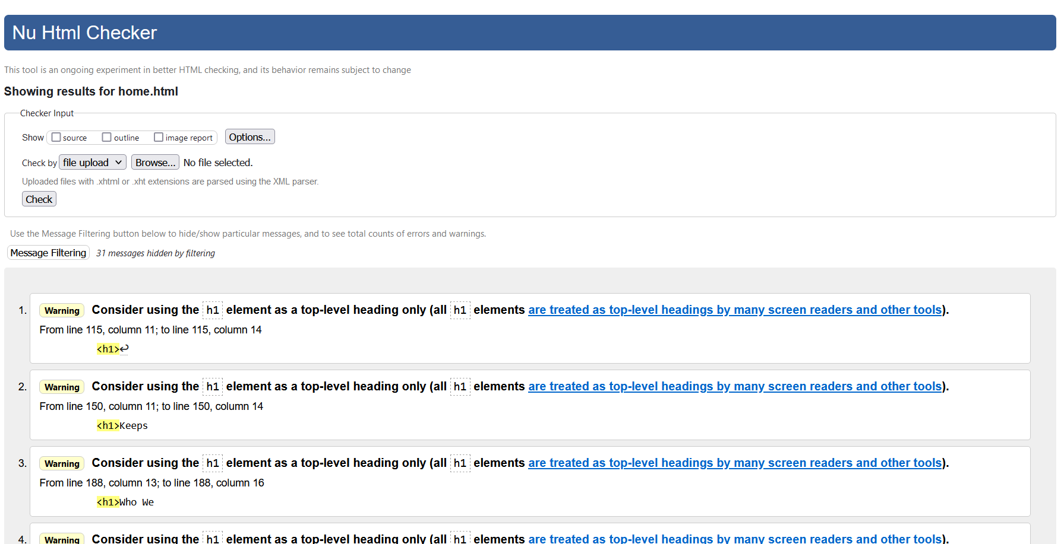

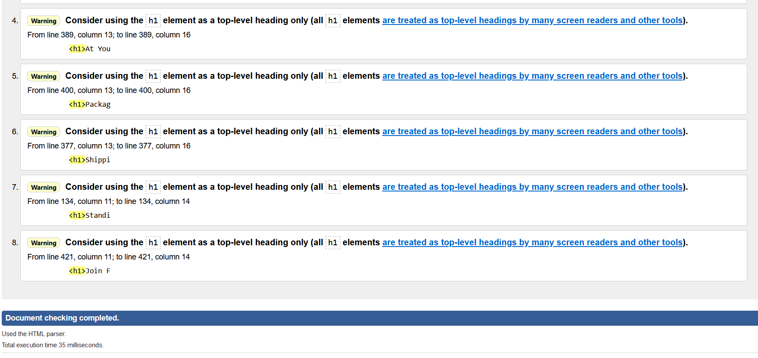

**Item Page Html Validation Checking**

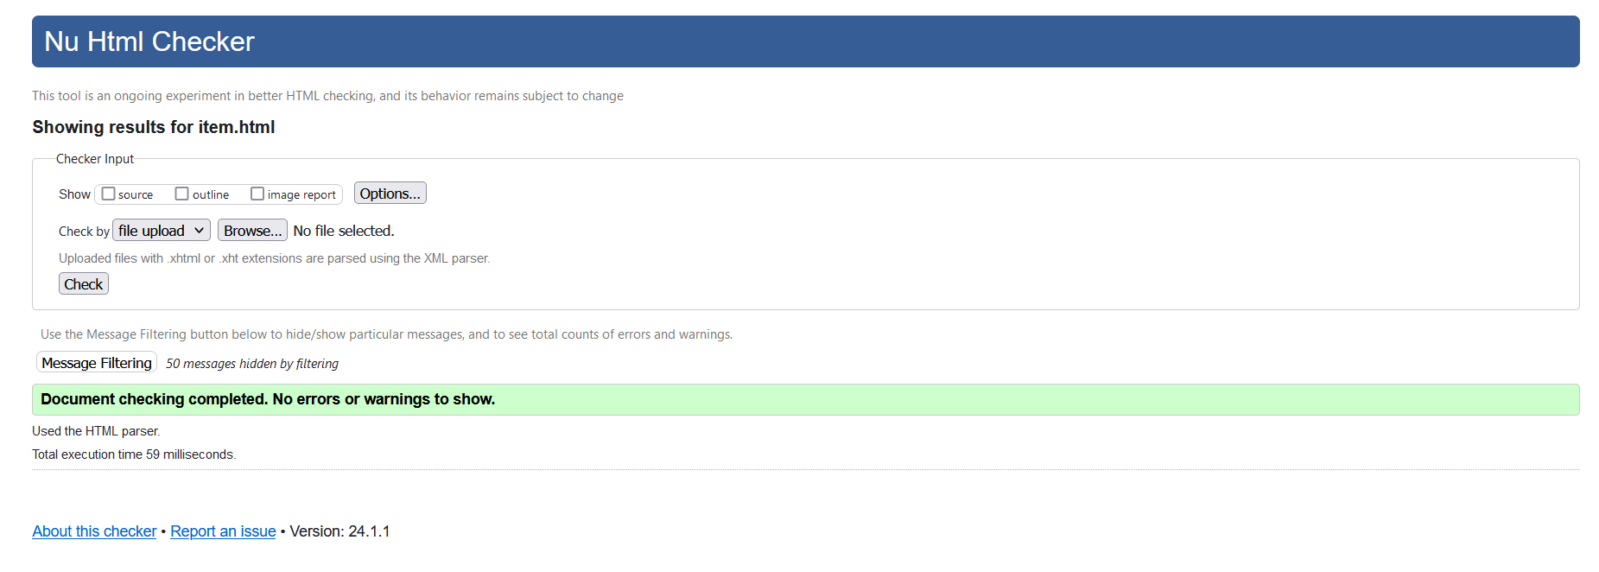

Item Page

**Item details Page Validation Checking**

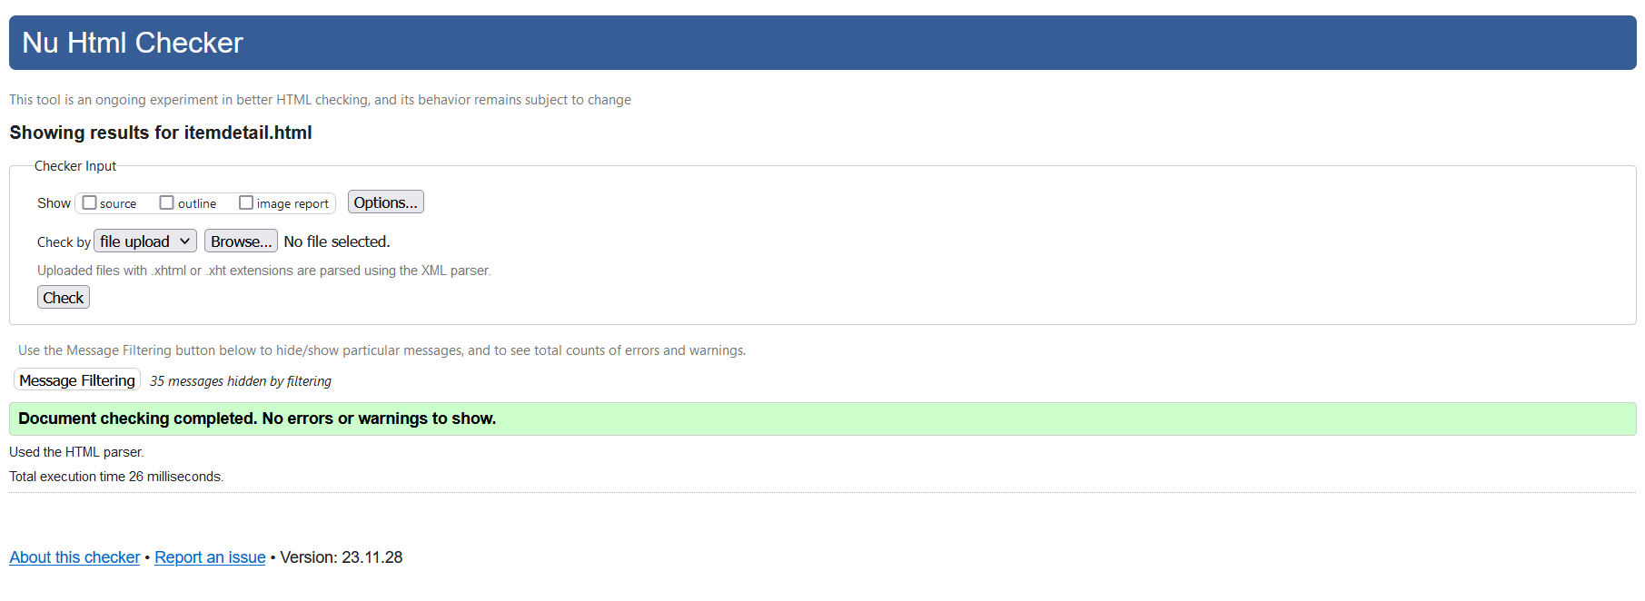

ItemDetails Page

**Basket Page Html Validation Checking**

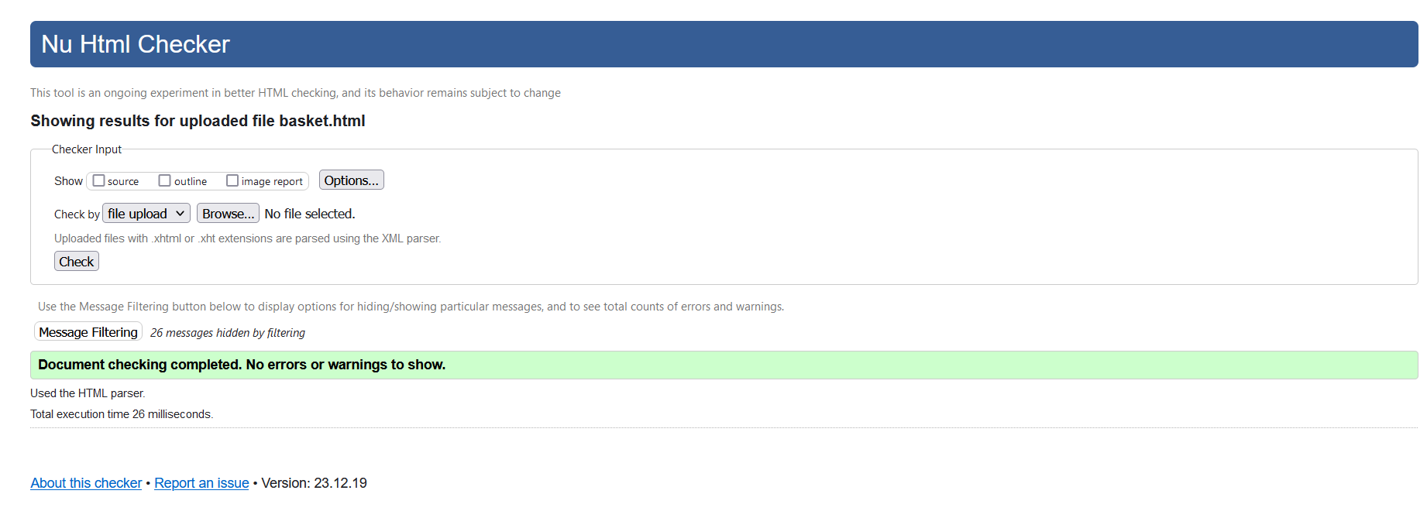

Basket Page

**Benefits Page Html Validation Checking**

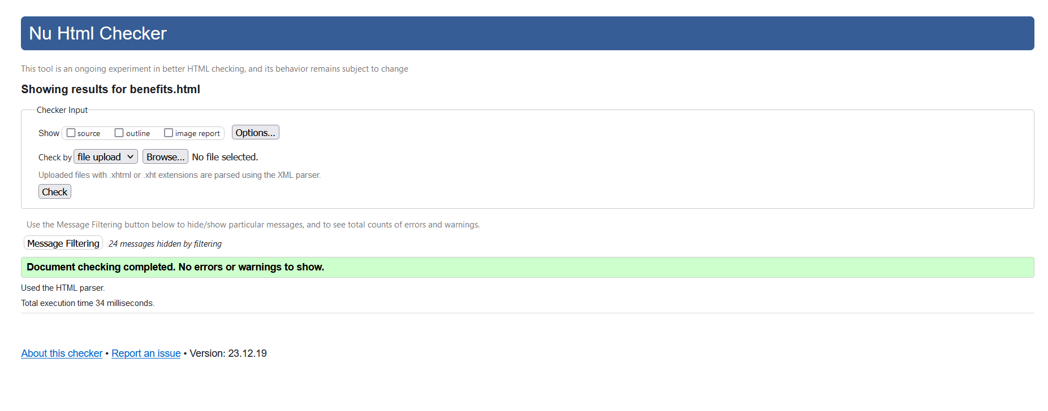

Benefits Page

**Contact Us Page Html Validation Checking**

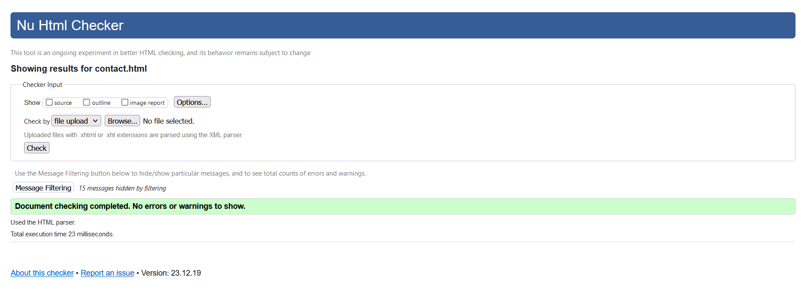

Contact Us Page

**CSS Validation Checking**

Before Correction

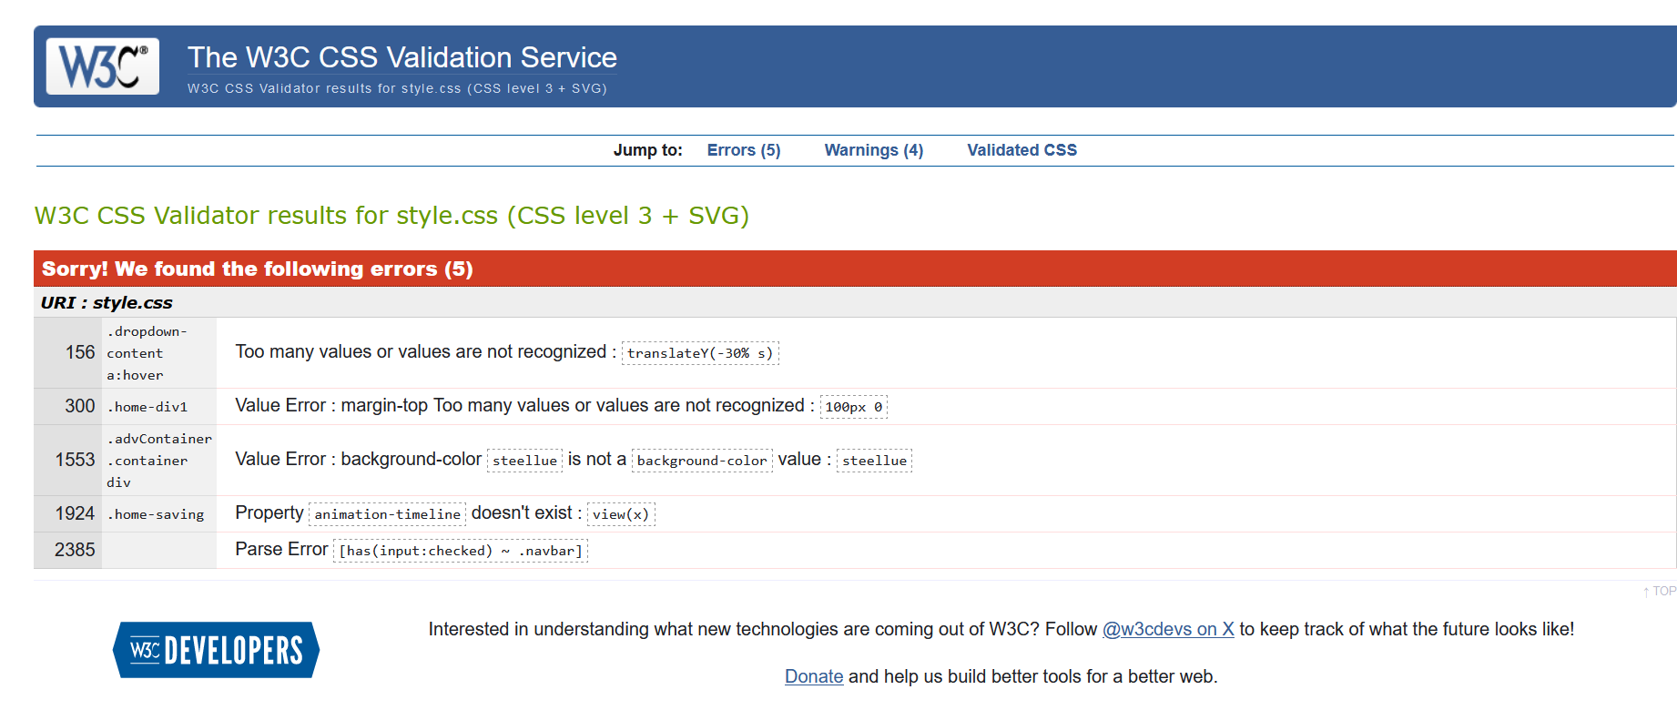

After Correction

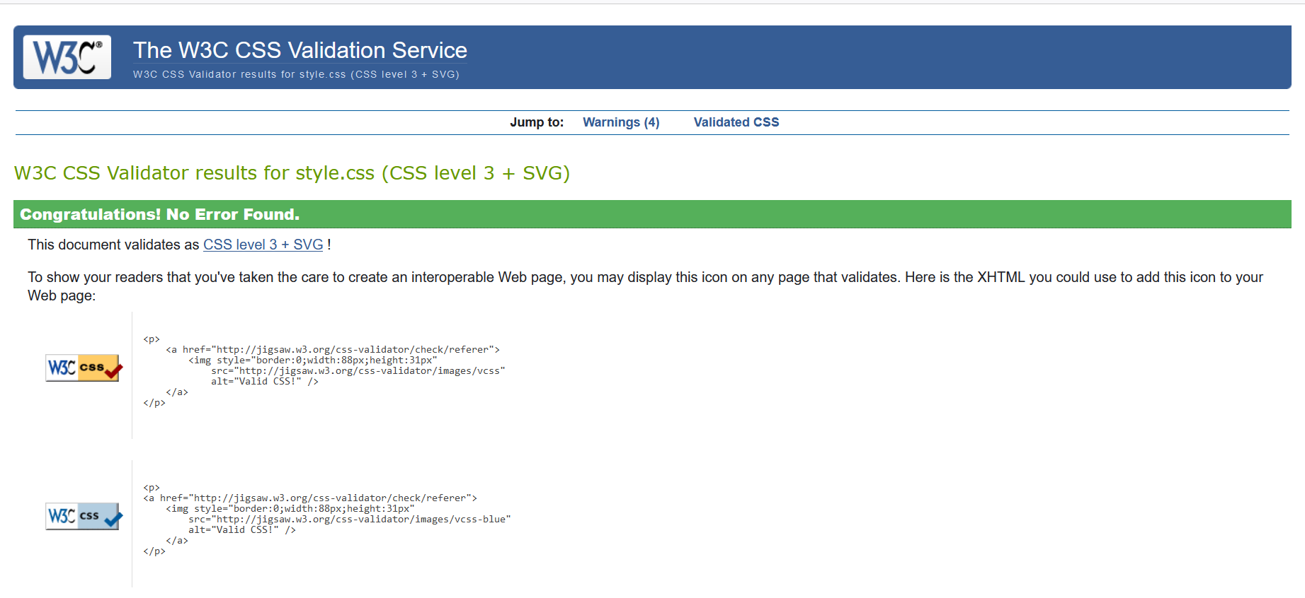

## **Using a relevant screen reader**

This website is tested with screen reader tool. Following screenshots are testing process.

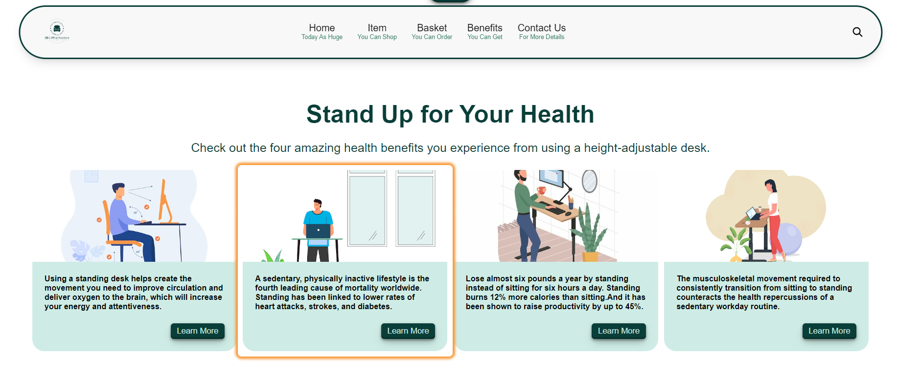

Benefits Page

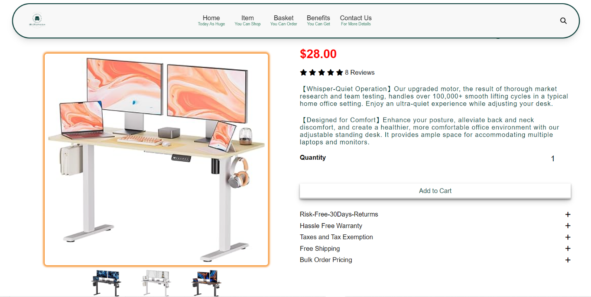

ItemDetails Page

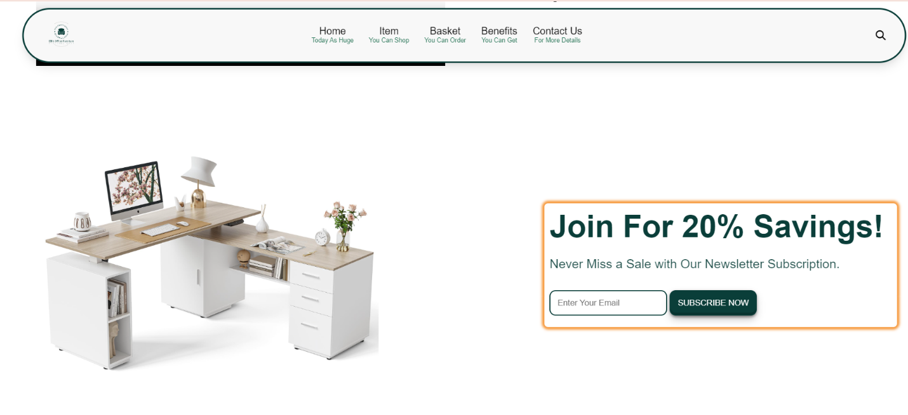

Saving section

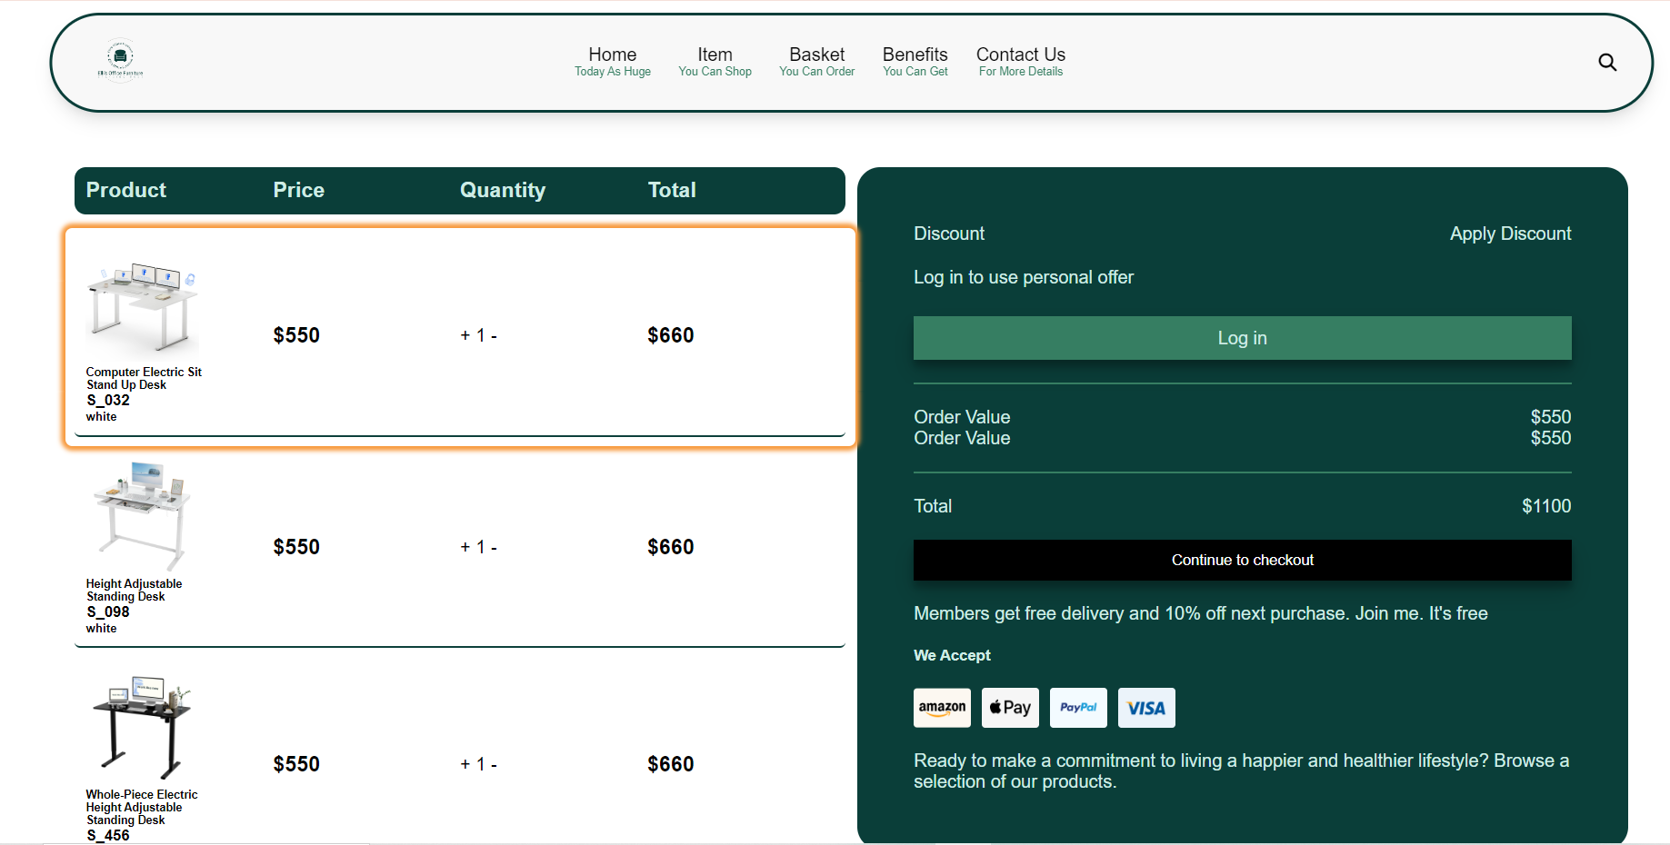

Basket Page

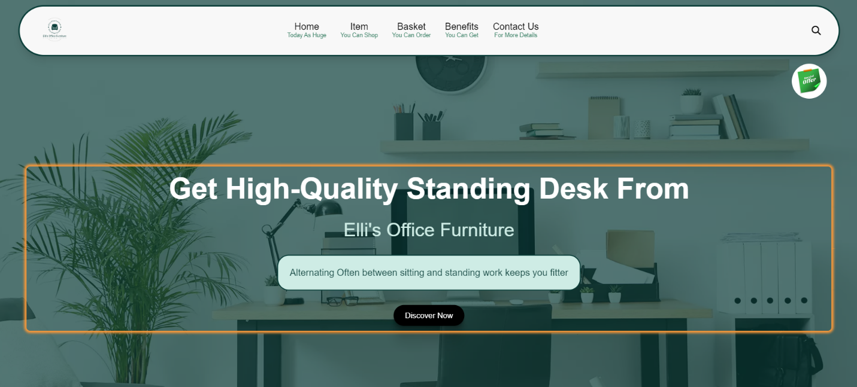

Home Page

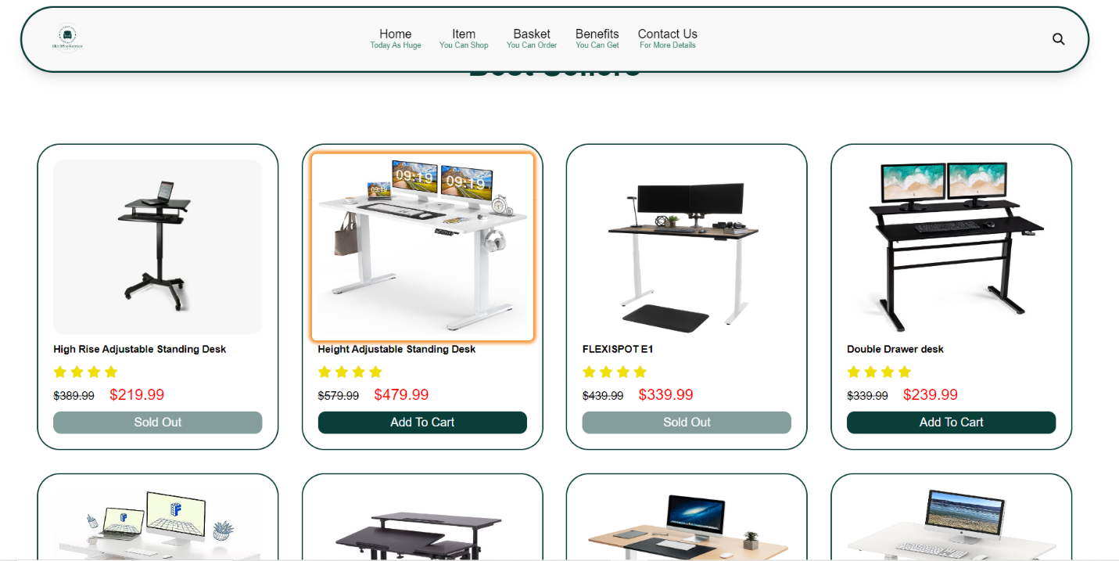

Item Page

## **How the site works for disabled users**

Website should be accessible for people with disabilities to see, understand, use, interact with, and contribute to the Website. In the website that had been made for this assignment, the images were added with “Alt” Text for disable user who can see. blind people and people with vision problems cannot access visual elements like pictures. “Alt” text can be read with screen reader for those people. Screen Reader are software applications that use a synthesizer or Braille display to read text on the screen. (Dudharejia, 2020). When designing webpages, dark green color on white background were used mostly for people who has vision problems.

## **Differences between TWO (2) browsers.**

**Using Firefox**

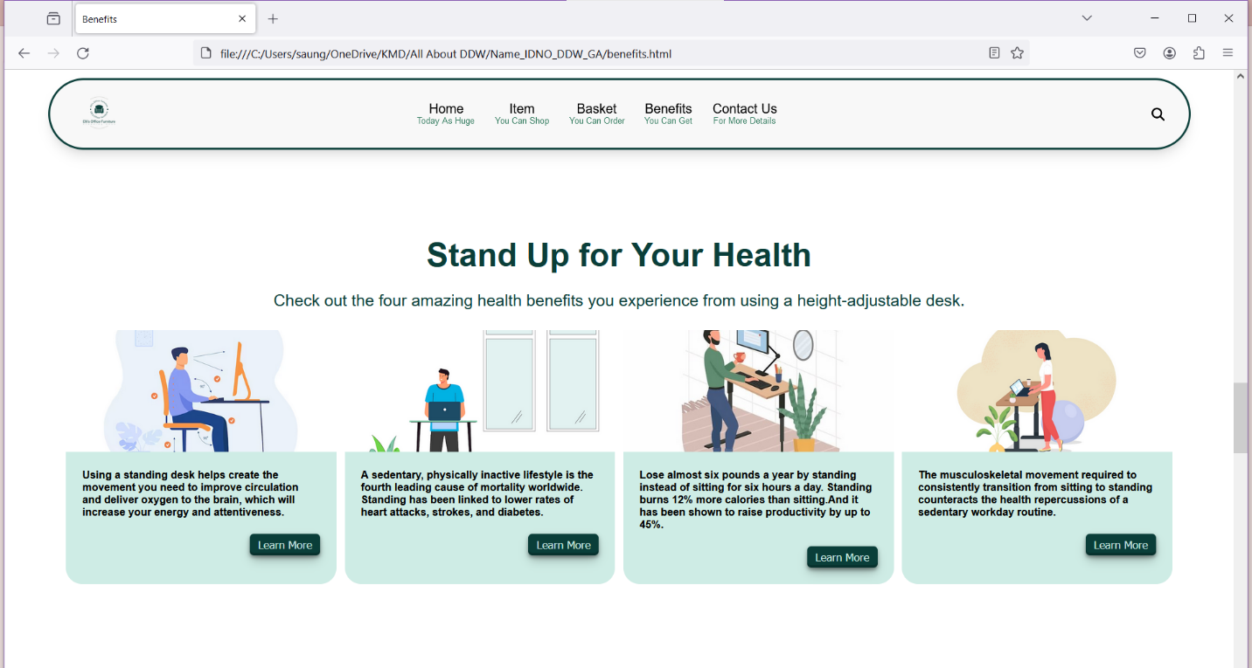

**Using Chrome**

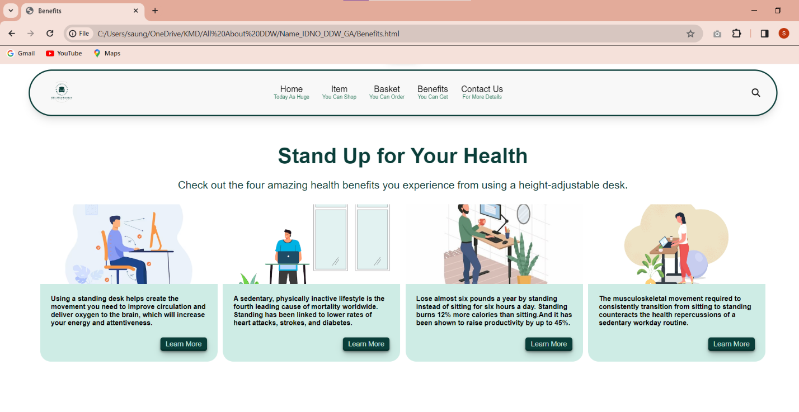

There is almost no change is over all view of Benefits page in two different browsers.

**Using Firefox**

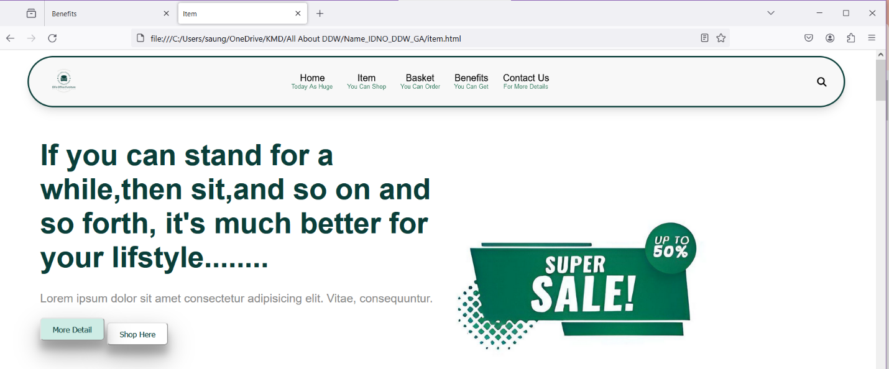

**Using Chrome**

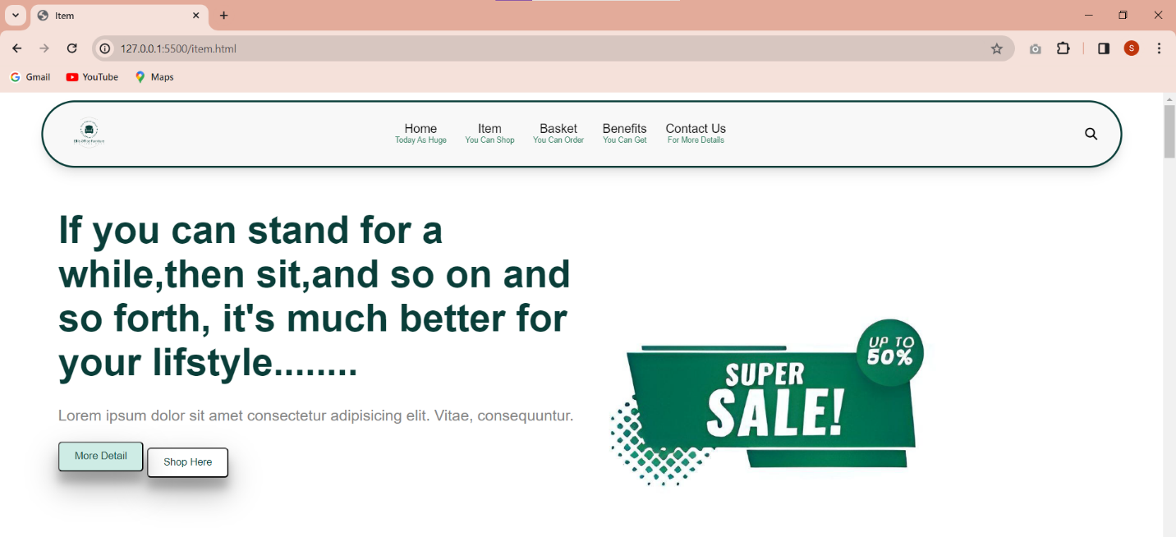

In Firefox, the button has no border when the hover is working. But in Chrome, the button is working with border line when the button was hovered. This is a really small different but it is obvious when the page is tested with two different browsers. Even though, the website is styled with CSS and did not add the border in button.

## **The amendments that had been made.**

When the website is tested is W3C Validation, the most common error is “name spacing” error In W3C Validation, name spacing is not allow. So, the name was needed to rename to fix that common error. And another error that is found when checking the website is “input” tag error. In the input tag, “type” attribute should not “button”. So, the “type” attribute needed to change from “button” to “text”. These all are errors from HTML code and the way it was solved.

**Before**



**After**



## **Test Report**

HTML files for all pages and CSS are tested with the W3C validation service (<http://validator.w3.org/>). In Home page HTML code, there are total (11) warnings. And another page is Item page, its HTML code is completely clear; example: no error and no warnings. ItemDetails page, Benefits page, Contact Us Page, and Basket page is like an Item page. At first, when the CSS file is checked, there are (5) errors. But after the correction, there are no error at all. For the overall view, small number of errors and warning are found in the website, but the errors are fixed it in time. Now, the website is perfect for all the users and also convenient for the people who have disabilities because of website accessibility.

## **The role of the W3C.**

W3C, The World Wide Web Consortium, it is a multinational organization that develops global web format rules and protocol standards to raise the caliber of websites everywhere. The role of the W3C is to unite IT professionals to develop website standards, focusing on creating protocols and guidelines for the growth and continuity of website technology. (cmlabs, 2022)

# **Task 4- Critical evaluation**

## **a) tools, techniques and software used to develop the website.**

The creation, testing, and deployment of websites and applications require a variety of tools and workflows in the dynamic and varied industry of web development. The development process and the website's overall success can be greatly impacted by the tools used. To evaluate the suitability of the methods, resources, and software utilized in the developing of a website, performance and compatibility are important factors to take consideration while assessing web development tools. And after that, evaluating web development tools, project's goal and scope should be top priority. The documentation and assistance provided by the tools are the third factor to take consideration when evaluating web development tools. (in, 2023)

## **b) Intuitive interfaces and User Experience.**

User experience design, UX design, is the process of making a product or service more functional, convenient, and easy to use in order to improve a user's level of pleasure. (Baker, 2022) In this website, the information that had given are clear and reach the details to understand the users. And buttons from the pages are related with all pages. If users want to know the one type of standing desk from “Item” Page, user need to click one button from this page, and then, user will reach “ItemDetails” page. And there is another evaluation for user experience. When the uses click the “More Details” button, they will automatically reach the “Benefit” page. In the “Benefit” page, there are so many details about health benefits when using standing desk. Positive user experiences are largely dependent on creating intuitive interfaces. Designers can create interfaces that satisfy users expectations and demands by prioritizing clarity, simplicity, and consistency.

## **c) TWO (2) accessibility features**

One of the most important aspects of developing an inclusive digital experience for people of all abilities is creating web forms accessible. In the website that had been created for this assignment, “Alt” texts were added in every images. In this way, people using assistive technology like dictation software would be able to understand the information of the website even if they are unable to view the image. (Hernandez, 2022). And the another one is using high-contrast colors. In this website, colors that have a high contrast ratio were used, such as dark-green, white, and also a mint-green to match the main color that is dark-green. White color was mostly used as a background-color. So, the text that ha dark-green color is stand out. For example, text should to be noticeable rather than disappear into the background. These are the two (2) accessibility features that included in this written website.

## **d) Recommend for further development**

Improvement of website for increased market share and business success. To increase engagement and conversion rates, manage the user experience and implement strategic improvements. Maintaining a simple, easy-to-use interface, using responsive design for a smooth cross-device experience, and simplifying navigation for quick access to information are all ways to improve user experience, or UX. (Gregor, 2022).

**References for images**

(Amazon, n.d.), (Office, n.d.)

(VIVO, n.d.), (Breach, n.d.)

(Buldesk, n.d.), (cmd-ltd, n.d.)

(Beyond, n.d.), (Page, 2022)

(ebay, n.d.),

(mart, n.d.)

(FEZIBO, n.d.)

(Belt, 2022)

(Vari, n.d.)

# **References**

Amazon, n.d. *Amazon.* [Online]   
Available at: https://www.amazon.com/  
[Accessed 11 January 2024].

Baker, K., 2022. *HubSpot.* [Online]   
Available at: https://blog.hubspot.com/marketing/ux-user-experience  
[Accessed 18 January 2024].

Belt, A., 2022. *House Beautiful.* [Online]   
Available at: https://www.housebeautiful.com/shopping/furniture/g32056855/best-standing-desks/  
[Accessed 11 January 2024].

Beyond, B. B. &., n.d. *Bed Bath & Beyond.* [Online]   
Available at: https://www.bedbathandbeyond.ca/Home-Garden/FLEXISPOT-Electric-Height-Adjustable-Standing-Desk-48-x-30-Inches-Home-Office-Desk-Whole-Piece-with-Ergonomic-Memory-Controller/36528854/product.html  
[Accessed 11 January 2024].

Breach, J., n.d. *Nuffield Health.* [Online]   
Available at: https://www.nuffieldhealth.com/article/standing-desk-health-benefits  
[Accessed 11 January 2024].

Buldesk, n.d. *Buldesk.* [Online]   
Available at: https://buldesk.com/gallery/  
[Accessed 11 January 2024].

cmd-ltd, n.d. *cmd-ltd.* [Online]   
Available at: https://www.cmd-ltd.com/advice-centre/ergonomics/standing-desk-benefits/  
[Accessed 11 January 2024].

cmlabs, 2022. *cmlabs.* [Online]   
Available at: https://cmlabs.co/en-id/seo-terms/what-is-w3c  
[Accessed 18 January 2024].

Dudharejia, M., 2020. *Search Engine Journal.* [Online]   
Available at: https://www.searchenginejournal.com/make-website-more-accessible/347450/  
[Accessed 18 January 2024].

ebay, n.d. *ebay.* [Online]   
Available at: https://www.ebay.com/itm/403541674680  
[Accessed 11 January 2024].

FEZIBO, n.d. *FEZIBO.* [Online]   
Available at: https://www.fezibo.com/products/l-shaped-corner-standing-desk?variant=40584505819205  
[Accessed 11 January 2024].

G, D., 2023. *Hostinger Tutorials.* [Online]   
Available at: https://www.hostinger.com/tutorials/what-is-css  
[Accessed 18 January 2024].

Gregor, 2022. *Linked in.* [Online]   
Available at: https://www.linkedin.com/pulse/19-simple-website-improvement-tips-any-business-can-use-saita-%E6%96%8E%E7%94%B0-  
[Accessed 18 January 2024].

Hernandez, 2022. *DreamHost.* [Online]   
Available at: https://www.dreamhost.com/blog/make-your-website-accessible/  
[Accessed 18 January 2024].

in, L., 2023. *Linked in.* [Online]   
Available at: https://www.linkedin.com/advice/3/what-best-way-evaluate-web-development-tools-skills-web-development  
[Accessed 18 January 2024].

mart, b. b., n.d. *big big mart.* [Online]   
Available at: https://bigbigmart.com/product/flexispot-48-w-ergonomic-home-office-height-adjustable-standing-desk-tempered-glass-top-white/  
[Accessed 11 January 2024].

Office, E. H., n.d. *Eco Home Office.* [Online]   
Available at: https://ecohomeoffice.com/products/zinus-betsy-smart-adjust-standing-double-desk-adjustable-height-desktop-workstation-white  
[Accessed 11 January 2024].

Page, S., 2022. *Total Wellness.* [Online]   
Available at: https://info.totalwellnesshealth.com/blog/benefits-of-standing-desks  
[Accessed 11 January 2024].

S, A., 2023. *Hostinger.* [Online]   
Available at: https://www.hostinger.com/tutorials/what-is-html  
[Accessed 17 January 2024].

Vari, n.d. *Vari.* [Online]   
Available at: https://www.vari.com  
[Accessed 11 January 2024].

VIVO, n.d. *VIVO.* [Online]   
Available at: https://vivo-us.com/products/desk-kit-1b6b-a2  
[Accessed 11 January 2024].

# Candidate checklist

Please use the following checklist to ensure that your work is ready for submission.

Have you read the NCC Education documents 'What is Academic Misconduct? Guidance for Candidates' and 'Avoiding Plagiarism and Collusion: Guidance for Candidates' and ensured that you have acknowledge all the sources that you have used in your work?

a

Have you completed the 'Statement and Confirmation of Own Work' form and attached it to your assignment? You must do this.

a

Have you ensured that your work has not gone over or under the recommended word count by more than 10%?

a

Have you ensured that your work does not contain viruses and can be run directly?

a